Using Kinect for Windows with XNA

Rob Miles

Kinect for Windows SDK

March 2012  
Edition 1.1

Contents

Introduction 3

Welcome 3

What you need to develop code 3

1 An Introduction to Kinect 3

1.1 The Kinect Sensor 3

1.2 Inside a Kinect Sensor Bar 5

1.3 Connecting the Sensor Bar 8

1.4 Installing the Kinect for Windows SDK 9

What We Have Learned 9

2 Writing Kinect Programs 11

2.1 Using the Kinect Video Camera 11

2.2 Using the Kinect Depth Camera 23

2.3 Using Sound with Kinect 32

What We Have Learned 36

3 Kinect Natural User Interfaces 37

3.1 People tracking in Kinect 37

3.2 Creating Augmented Reality 43

3.3 Adding Voice Response 53

What We Have Learned 58

# Introduction

## Welcome

These notes are an introduction to the Microsoft Kinect sensor bar and the Microsoft Kinect SDK. I’m assuming that you have a working knowledge of the C# programming language, the XNA framework and program development using Visual Studio.

## What you need to develop code

All the development tools that you need can be downloaded for free. The first thing you will need is the Windows Phone SDK. You can download it from here:

*http://create.msdn.com/*

You might think it strange to use the Windows Phone SDK, but this contains the latest version of XNA and can be used to create XNA programs for Xbox 360 and Windows PC as well as Windows Phone.

You will also need to download the Kinect for Windows SDK which you can find here:

*http://kinectforwindows.org/*

This installs the USB drivers for the sensor components and the library file that contains the Kinect for Windows SDK.

# An Introduction to Kinect

The Microsoft Kinect sensor provides a genuinely new way for users to interact with their computers. The Kinect sensor bar contains three forms of sensor. It can detect video using a high resolution webcam, sound using an array of microphones and depth using a special “Depth Camera”..

## The Kinect Sensor

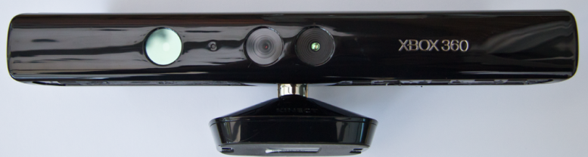

The Kinect has set a record as the fastest selling gadget ever, with over 8 million sold in the 60 days after it went on sale. Xbox 360 owners connected the device to their consoles and were able to play games that could actually see the players moving around in the play area. The Kinect was sold as the device that makes “you” the controller. It does this by introducing a new kind of camera that could view a scene and measure the “depth” of objects in front of the Kinect sensor bar. This allows the software in the controlling device to build an image of the scene in front of the sensor. This can detect the position and orientation of players in front of the sensor and build a virtual “skeleton” that describes where they are and how they are standing.

### The Kinect Sensor and the Xbox 360

Software running inside the Xbox 360 console decodes the depth information produced by the sensor and generates a digital “skeleton” that describes the position of the person playing the game. A game can then directly interact with the movement of players, football games can detect kicking actions, golf games can track golf swings and so on. For the record, my favourite games for the Kinect are Kinect Sports, Dance Central 2 and the Gunstringer.

The Kinect sensor is not just intended for gameplay use, the microphones provide good quality audio input which is also used to allow the Xbox 360 to implement effective voice recognition. Xbox 360 owners can use the Kinect voice input to select movies to watch, control media playback and search the internet.

The Kinect sensor is connected to an Xbox 360 console through a USB connection. This connection is also present on computers. From the moment of its release there was a lot of speculation about the possibility of using the Kinect sensor bar on devices other than games consoles. A number of software developer kits (SDKs) appeared which provided some access to devices in the sensor but in mid-2011 Microsoft released a beta version of an official “Kinect for Windows SDK”. The final version of the SDK is now available. It has been used for all the examples in this text.

### The Kinect for Windows Sensor

The Kinect for Windows sensor bar is based on exactly the same technology as the sensor created for the Xbox 360. However, the internal firmware has been adjusted to allow the depth sensor to work over a larger distance range. The Kinect for Windows sensor can register depth values within 40cm of the sensor, rather than the 80cm supported by the Xbox 360 sensor. This provides the potential for the Kinect technology to be used close up by a single user, something that the Xbox device is not intended for.

The Kinect for Windows sensor is the only sensor bar that is formally approved by Microsoft for use in products based on the Kinect for Windows SDK. The Kinect for Windows SDK will work with the Kinect for Xbox sensor, but this is intended for hobbyist and prototype development.

### The Microsoft Kinect for Windows SDK

The Kinect for Windows SDK is provided as an assembly which can be included in any Windows PC program that wishes to use the features of the sensor bar. There are versions of the drivers for unmanaged code (C++) and also for managed code (Visual Basic .NET and C# .NET). The unmanaged and managed drivers provide access to the same set of sensor features.

#### Managed and Unmanaged Code

The words “managed” and “unmanaged” refer to the way that code runs on a computer. A managed program is tightly constrained in terms of what it can do when it runs. Attempts to access memory and hardware are carefully monitored so that a program written for managed code cannot attack the operating system or hardware of the computer it is using. This makes for very secure software, but it does bring a speed penalty, in that the computer has to spend time checking what the program is doing.

Managed programs are often supplied in an intermediate language which has to be converted into the native machine code of the underlying computer before it can be executed. Using an intermediate language brings benefits in portability (the same intermediate code can be converted for execution on a range of platforms) and safety (the intermediate code can be more easily verified than native machine code) but this brings further speed reductions as programs written in an intermediate language cannot be customised for the specific behaviours of an underlying processor. You can think of a managed program as a bit like a car with airbags, anti-lock braking and safety belts. All of these things help to make the car safer, but their extra weight and complication will slow the car down and make it larger.

An unmanaged program is given direct access to the hardware of the computer. An unmanaged program is supplied as a compiled binary for a particular computer type that is simply loaded into memory and started. Unmanaged programs can begin running the instant they are loaded into the computer and a developer can customise a binary program for a specific hardware platform. However, they require the programmer to do more work when setting up and using resources.

Modern computers use the hardware of the computer processor to ensure that unmanaged code is not able to damage the underlying computer or operating system. However, if an unmanaged program goes wrong it is much harder to work out what happened as faults such as memory corruption are much harder to detect. You can think of an unmanaged program as a bit like a go-kart. This has the absolute minimum required to make a vehicle that can be driven and steered. As a consequence it can go a lot faster than a heavier but much safer car. However, if the go-kart crashes the potential for damage to the driver is much greater.

In this text we are going to use the managed drivers and the C# language for the program development. If you prefer to use Visual Basic you will find that the classes in the Kinect for Windows Software Development kit are very easy to use from that language too. The power of a modern computer is such that it can run managed code with sufficient to produce a good user experience.

## Inside a Kinect Sensor Bar

If you take your Kinect sensor to pieces (please don’t do this) you will find a highly complex device which contains a collection of sensors and a serious amount of processing power. In fact there is so much processing going on inside the sensor bar that there is even a tiny fan which runs to keep all the electronics cool.

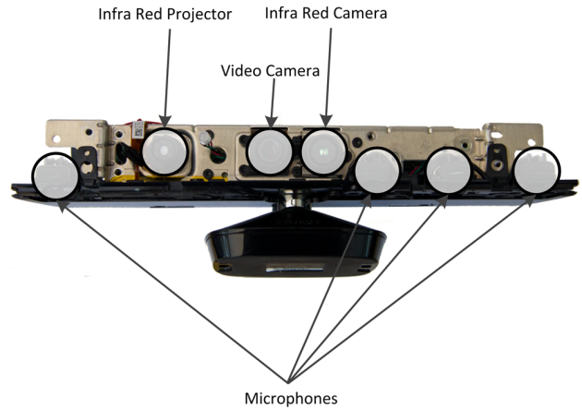

Above you can see a sensor bar with the enclosure removed. The sensors have all been highlighted on the diagram.

### The Kinect Video Camera

The Kinect video camera provides high resolution video images to the host device. It can work at a variety of resolutions up to 1280x1024 pixels, although the resolution that is normally used is 640x480.

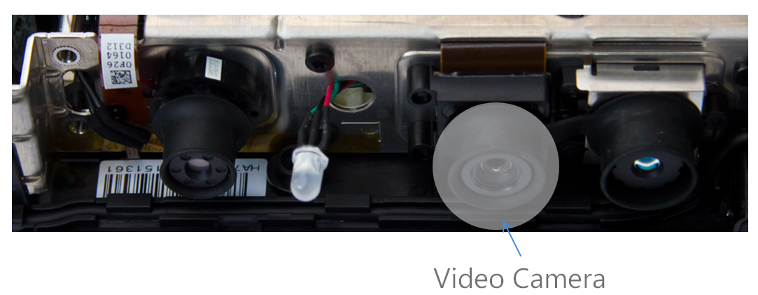

The USB drivers provided with the Kinect SDK allow the camera to be used for video conferencing as well as with Kinect software.

### The Kinect Microphones

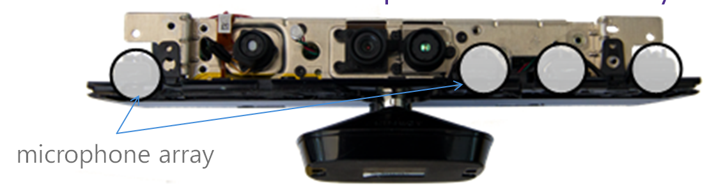

The Kinect sensor bar contains four microphones which are positioned as shown above. Note that these are not installed so that the Kinect can capture multi-channel stereo sound. Instead they are used to allow the Kinect to “focus” on individual sound sources. The Kinect contains Digital Signal Processing (DSP) components that process the sound received from the microphones. The software running inside the sensor knows the physical separation between each microphone and the speed at which sound travels through the air. The software can then perform analysis of the incoming signals to identify the direction of a particular sound source and allow the sensor to ignore unwanted sounds and echoes.

The reason that the sensor does all this extra work is that it is trying to give the clearest possible audio signal which can then be analysed for speech recognition. It also makes it possible for the Kinect to recognise different speakers in a situation where more than one person is giving voice commands.

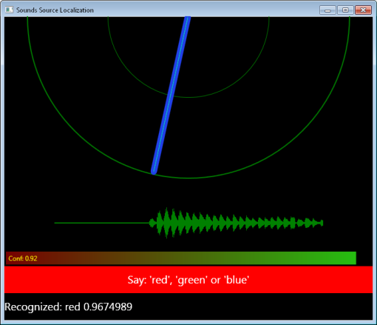

Above is the output from one of the sample applications provided as part of the Kinect for Windows SDK. This program uses the Microsoft Speech Platform to recognize speech received by the Kinect sensor. The program also displays the direction of the speech relative to the sensor.

### The Kinect Depth Camera

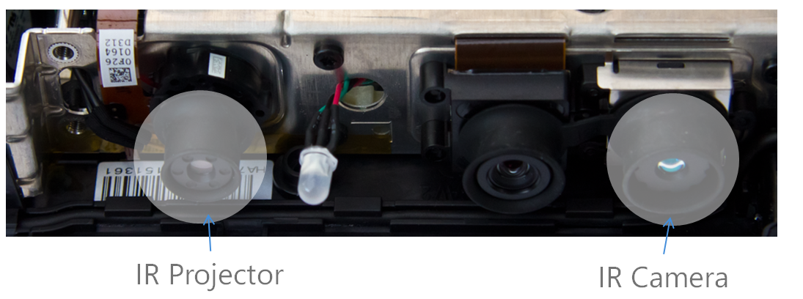

There are two elements to the Kinect depth camera. The first is the Infra-Red projector that projects a field of dots onto the scene in front of the sensor bar. The second element is an Infra-Red camera that views the dots in the scene. The position of the dots in the scene the camera views depends on the position in the scene from which they were reflected.

You notice this effect yourself as you walk towards a doorway. The left and right sides of the entrance appear to move apart as you get closer to it. They are not actually moving, but because they are closer to you they fill more of your field of view.

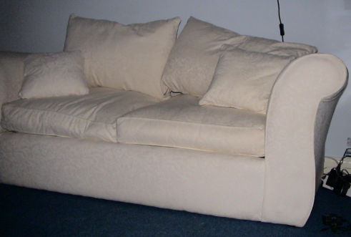 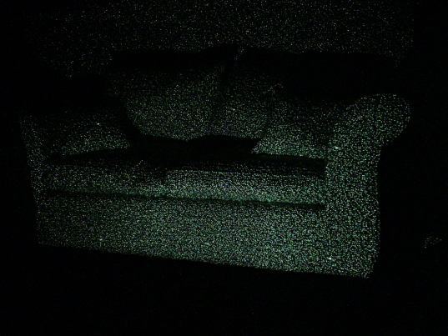

Above you can see two images of the same scene. The left hand image shows what the Kinect video camera sees. On the right you can see the pattern of dots that the Infra-Red camera sees. Some of the dots are bright “alignment” dots; others are used for more precise positioning.

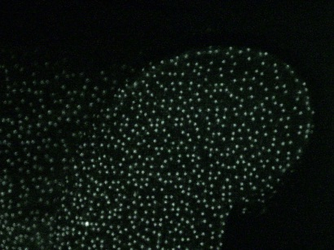

Above you can see a close-up of the dot field on the arm of the sofa Note how the spacing between the dots increases on the back of the sofa at the left of the image. The Kinect sensor uses this information to compile a “depth map” of an image which sets out how far each element in the scene is from the camera.

The depth sensor works remarkably well, but it does have some limitations:

* If objects are very close to the sensor the dots become so close together that the sensor cannot separate them. It is not possible for the Xbox version sensor to measure distances within 80cm of the sensor. The Kinect for Windows sensor will work to within 40cm.
* Because the sensor camera and the Infra-Red projector are in different places on the sensor bar it is possible for objects close to the camera to cast shadows in the Infra-Red grid which obscure parts of the view.
* The further away an object gets the greater the dot spacing and the less accurately the sensor can determine the distance of parts of the scene between the dots.

Having said this, the sensor will give very useable results from 80mm to 3.5m from the sensor, with a “depth resolution” of 320x240 readings on each scene.

#### Kinect Skeleton Tracking

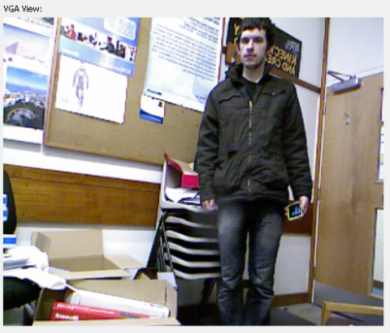 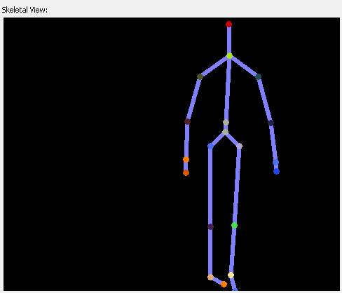

A program can use the depth information from the sensor to detect and track the shape of the human body. The Kinect SDK will do this for our programs and provide skeletal position information that can be used in games and other program. Above you can see the output from two windows. One shows the video view and another has drawn lines that show the skeleton that has been decoded from the depth information for this frame.

The skeletal tracking in the Kinect SDK can track six skeletons at the same time. For four of the bodies only simple location is provided but two will be tracked in detail. For those two bodies the SDK will provide the position in 3D space of 20 joint positions. The software will infer the position of joints if it is not able to view their position exactly, for example of the user is wearing clothing such as a skirt that obscures their limbs.

## Connecting the Sensor Bar

The Kinect uses the USB 2.0 standard to communicate with the host device. The original (white) Xbox 360 consoles have a USB connection on their rear which can be used to connect the sensor. However, because the sensor uses more power than the 0.5amps that are provided by a USB connection the Kinect sensor bar is supplied with a power supply that will deliver the 1.5 amps required to drive the sensor. The newer (shiny black) Xbox 360 design has a custom USB connection on its rear which provides the extra power for the Kinect without the need for an extra power source.

The cable running from the Kinect sensor is fitted with a special kind of USB plug with a corner “blocked” off. This plug will only fit in the socket in the Kinect power supply cable or on the back of a new design Xbox 360. If you try to put this plug into a USB socket on a standard PC it is very likely you will break something and the Kinect sensor will not work.

With the above proviso it is very easy to plug a Kinect into a Windows PC, in fact you can work with a Kinect purchased for console use with a Windows PC very easily (although you might get complaints from the rest of the family if you stop them from being able to play their favourite games).

When the Kinect is supplying depth, video and sound information to the host computer it makes a lot of use of the USB connection. For this reason it is best to ensure that the Kinect sensor is the only device connected to a particular USB port and not to connect it via a USB hub which has other devices connected as well.

The minimum hardware requirements for a PC hosting the Kinect sensor are set out as a dual core machine running at 2.66 GHz with at least 2G of memory. The machine can be running a 32 or 64 bit version of windows.

To develop Kinect for Windows Programs you will need a copy of Visual Studio 2010 (the Express version works fine) and the .NET Framework version 4.0 (which is usually already installed). If you want to create applications that use speech input you will need to install the Microsoft Speech Platform SDK, version 11.

## Installing the Kinect for Windows SDK

The programs will make use of the resources that are part of the Kinect for Windows SDK, which must have been installed on the system that you are using. The SDK can be downloaded from here:

*http://kinectforwindows.org/*



The software does not take very long to load and also installs the USB drivers for the Kinect sensor bar along with documentation and sample code. It is important that you do not connect the Kinect sensor bar to your computer before you have installed the SDK. The optimal sequence for Kinect SDK satisfaction is as follows:

1. Remove any pre-release drivers for the Kinect sensor bar. If you have used any third party (non-Microsoft ) Kinect drivers you should make sure that these are completely uninstalled before continuing. You should also make sure that any Kinect device drivers that may have been installed along with third party software are also completely removed.
2. Plug the Kinect sensor bar into an Xbox 360 console which is connected to Xbox Live. This will install any updates to the firmware in the Kinect sensor bar. The latest version of the Kinect sensor bar firmware works best with the Kinect for Windows SDK.
3. Download and install the Kinect for Windows SDK.
4. Connect the Kinect sensor bar to the Kinect sensor bar power supply that was supplied with it. Connect the USB plug in the Kinect sensor bar power supply to a free USB port on the host computer. This should cause all the USB device drivers to be detected and installed.
5. You can now open the “Sample Browser” application and run the Kinect Explorer program which demonstrates the depth and video cameras and shows the skeleton tracking provided by the SDK.

If you want to run Kinect applications on any PC you will need to install the SDK so that the library files are available on that machine too. You can also download a runtime version of the Kinect drivers from here:

*http://download.microsoft.com/download/E/E/2/EE2D29A1-2D5C-463C-B7F1-40E4170F5E2C/KinectRuntime-v1.0-Setup.exe*

This is for use by anyone who wishes to run Kinect programs (perhaps ones that you have written) but does not want to install the SDK.

## What We Have Learned

1. The Kinect sensor originally produced as a new form of input sensor for the Xbox 360 console. It is now available for Windows PC.
2. Software can be developed on Windows PC that uses the Kinect sensor by installing the Kinect for Windows Software Development Kit (SDK). It contains drivers for both managed (C# and Visual Basic .NET) and unmanaged (C++) applications that want to use the sensor.
3. You can produce Kinect programs for hobby and private purposes. If you wish to sell a program that makes use of the Kinect for Windows SDK this should be based on the Kinect for Windows version of the sensor bar. The Kinect for Windows SDK can be downloaded from http://kinectforwindows.org/
4. The Kinect sensor bar contains a high definition camera, a microphone array and a depth sensor.
5. The Kinect depth sensor uses infra-red range finding to build a depth map of the scene in front of it. It can measure the distance of objects from the sensor in the range 80cm to 3.5 meters. The Kinect for Windows sensor can measure distances as close as 40cm.
6. The Kinect for Windows SDK can use the depth camera data to perform skeletal tracking of users in front of the sensor. This can track up to 6 bodies, two of them in high levels of detail.
7. The Kinect for Windows SDK is provided as a class library that can be used in programs that wish to make use of the Kinect sensor facilities.

# Writing Kinect Programs

In this section we are going to find out how to create an XNA program that uses the Kinect sensors. We are going to start by creating a program that uses the Kinect video camera.

## Using the Kinect Video Camera

The first thing we are going to do is discover how to use video input to an XNA game program. To do this the game must set up a link to the Kinect sensor bar and then activate the camera in the sensor. It must then process new video frames as they arrive from the camera and display them as textures on the screen.

### Adding the Kinect Libraries to an XNA game

The Kinect SDK is packed into a Dynamic Link Library (DLL) supplied as an assembly that can be added to any application that wants to use the Kinect device. Note that there are no new project types added to Visual Studio when the Kinect for Windows SDK has been installed, instead the installation just places a library file on your machine which can be added to solutions that you create that are to use the Kinect device.

This means that you can add Kinect support to any Windows program whether it is a Windows Presentation Foundation (WPF) application or an XNA game. In this text we are going to focus on using Kinect in XNA games, but we will also find out how to add Kinect to a WPF program.

We can make a Kinect camera application from scratch by starting with a new XNA game project.

1. Open Visual Studio and use the **File>New>Project** option on the menu to open the New Project dialog.
2. Select the **XNA Game Studio 4.0** template and pick **Windows Game (4.0)** from the template options.
3. Give the game the name **KinectCam**, as shown below. Click **OK** to create the project.

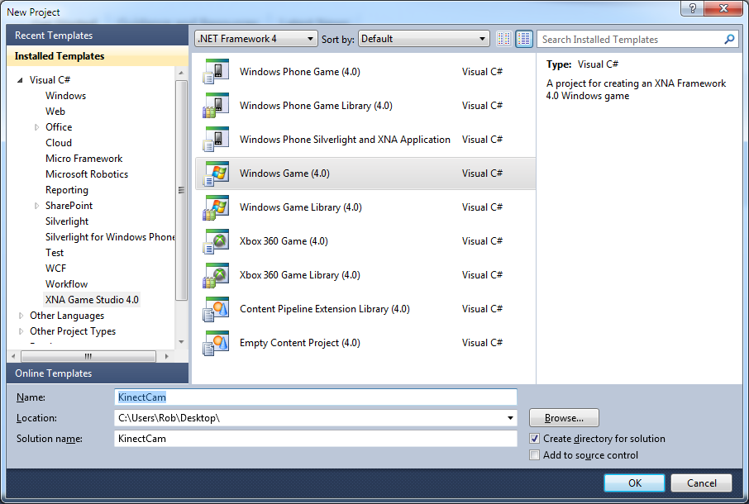

1. If we run this program it will display the familiar Blue Screen of an empty XNA game. The next thing we need to do is add the Kinect libraries to the Visual Studio project.



1. Right click on the **References** item in the **KinectCam** project as shown above and then select **Add Reference** from the context menu that appears. This should produce the **Add Reference** menu as shown below.

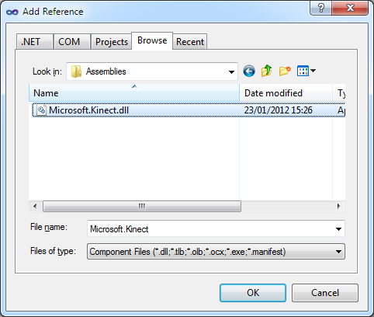

1. The library you want to add is usually in the location shown below:

C:\Program Files\Microsoft SDKs\Kinect\v1.0\Assemblies\Microsoft.Kinect.dll

1. Navigate to the required location and add the dll file as shown above. Note that if you have not used the default Kinect for Windows SDK installation you might have to look in a different location for the required file. When you have found the file click **OK** to add the reference.

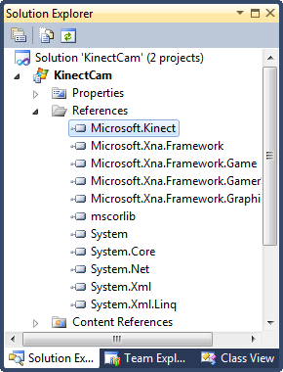

1. The References in the solution now include the **Microsoft**.**Kinect** item as shown above.
2. The final thing you need to do is add some using directives that will make the program easier to understand.

using Microsoft.Kinect;

1. Add the above lines at the top of your program, underneath the other using statements.

We now have a program that includes the Kinect libraries. The next thing we need to do is create some code that actually uses the Kinect sensor.

### Creating a Kinect Runtime and setting it up

The KinectSensor class is provided as part of the Kinect for Windows SDK libraries. It is the bridge between your program and the Kinect sensor bar. When we write an XNA game we use an instance of the class GraphicsDevice to manage interactions with the graphics display adapter. The KinectSensor class does the same job, but for the Kinect sensor. When our program runs it will create an instance of the KinectSensor class and then use this to control the Kinect sensor bar.

1. Open the C# source file **Game1.cs** and find the declaration of the class **Game1**. Add a declaration of a **KinectSensor** reference underneath the declaration of the **SpriteBatch** value:

public class Game1 : Microsoft.Xna.Framework.Game  
{  
 GraphicsDeviceManager graphics;  
 SpriteBatch spriteBatch;  
  
 KinectSensor myKinect;

1. The next thing we need to do is add the code that will actually create the **KinectSensor** instance and start some Kinect services. The game can do this in the **LoadContent** method which is created as part of the XNA game project and is called when the game starts running. We have to make the method set the value of **myKinect** to refer to the Kinect sensor that the program will be using. This will be the first (and usually only) sensor plugged into the machine. The Kinect sensors installed on a machine are provided by the **KinectSensor** class as a collection. We can get hold of the first Kinect in the list by asking for the one at subscript zero in the list. Add the statement below to the **LoadContent** method in your program.

myKinect = KinectSensor.KinectSensors[0];

1. Now that the program has an object that can be used to control a Kinect sensor it can start giving the sensor orders. The first thing it must do is initialize the sensor and tell the sensor what kind of data to produce. We can ask the sensor for several different kinds of data. The first program is just going to use the colour video signal and so it must call enable it as follows.

myKinect.ColorStream.Enable();

1. When the program starts running it will configure the Kinect to generate a stream of colour images. The next thing the program must do is to tell the sensor what to do when it has captured some new video data to be displayed. The program will use an event handler to do this. Effectively it will say to **myKinect** “When you get a new frame to display, call this method which will draw it on the screen”. You can get Visual Studio to generate the event handler method for you. Start by typing the following into the **LoadContent** method just underneath the call of **Enable**:

myKinect.ColorFrameReady +=



1. Visual Studio will offer to create a connection to the event handler for you by popping up a helpful dialog as shown above. Press **Tab** to insert the suggested code.



1. Visual Studio will now offer to create the event handler for you by popping up another helpful dialog. Press **Tab** again to insert the suggested code. We will go back and insert the actual program code later.
2. The final thing we need to do is actually switch on the Kinect sensor and start it producing a data stream. The program can do this by calling the **Start** method.

myKinect.Start();

At the end of all this hard work our LoadContent method should look like this.

protected override void LoadContent()  
{  
 // Create a new SpriteBatch to draw textures.  
 spriteBatch = new SpriteBatch(GraphicsDevice);  
  
 myKinect = KinectSensor.KinectSensors[0];  
  
 myKinect.ColorStream.Enable();  
  
 myKinect.ColorFrameReady +=   
 new EventHandler<ColorImageFrameReadyEventArgs>  
 (myKinect_ColorFrameReady);  
  
 myKinect.Start();  
}

When the game starts running the Kinect will be initialised and started running. Each time the Kinect has a new video frame from the camera the Kinect will generate an event to deliver that new frame. Unfortunately at the moment this will just cause the program to throw an exception because the event handler is not complete.

We also need to remember that at the moment there is no error handling in our game. If the user starts the program running with no Kinect plugged in the game will fail without giving a sensible message. This is not acceptable behaviour, but for now it lets us focus on the Kinect aspects of program creation. We will consider how to display sensible error messages a little later in this section.

### Displaying a Video Texture

We are writing a program that will display a video frame on the screen each time it gets a new one. If you have used XNA before you will know that an XNA program uses the SpriteBatch.Draw method to draw on the screen. This can be given a texture to draw and a rectangle to draw it in. These need to be added to the program and the XNA Draw method needs to perform the drawing action.

1. First we are going to add the **Texture2D** and the **Rectangle** items that will be needed to draw the video output. These should be added at the top of the game class, underneath the declaration of the variable **myKinect**.

Texture2D kinectVideoTexture;  
Rectangle videoDisplayRectangle;

1. Now the program needs to set the size of the display rectangle. A good place to do this is in the **Initialize** method that is called by XNA to set up the game when it runs. Add the following statement to the **Initialize** method.

videoDisplayRectangle = new Rectangle(  
 0, 0,   
 GraphicsDevice.Viewport.Width, GraphicsDevice.Viewport.Height);

1. When the program starts running it will now create a draw rectangle in the **Initialize** method and then setup the Kinect when **LoadContent** is called. The final thing that needs to be added is the draw behaviour for the image. This should be placed in the **Draw** method for the game:

spriteBatch.Begin();  
  
if (kinectVideoTexture != null)  
{  
 spriteBatch.Draw(kinectVideoTexture, videoDisplayRectangle,  
 Color.White);  
}  
  
spriteBatch.End();

1. The code above will only try to draw the texture if one has been created. The reason for this is that the Kinect sensor takes a little while to start generating images, but the game will start drawing as soon as it runs. The test above makes sure that the program does not try to draw anything until it exists.

We now have a program that will draw a texture if one exists. However it will still fail to run correctly because it is missing the part of the program that creates the image texture to be drawn. This must run each time the Kinect camera makes a new frame of video.

### Creating a video texture from a Kinect image frame

The Kinect video camera will produce a new video frame around 30 times a second. Each time a new frame is produced the Kinect SDK has been made to call a method to deliver the frame information. We have connected a method to this event, but at the moment the method doesn’t do anything:

void myKinect_ColorFrameReady(object sender,  
 ColorImageFrameReadyEventArgs e)  
{  
 throw new NotImplementedException();  
}

If this method is ever called it will cause our program to stop because it will throw an exception. We need to replace the exception throwing behaviour with something that takes the image from the Kinect camera and puts it onto the kinectVideoTexture variable that we have set up to display it.

1. The method is going to extract the video data from the Kinect video frame and store it in an array of bytes. The program can use the same area of storage for each frame in succession. This array must be declared in the program at the top underneath the other game variables:

byte[] colorData = null;

1. The variable **colorData** is not set to an array by this statement. The very first time the event handler runs the method will create an array of the required size, as we shall see later.
2. Now we need add code to the myKinect_ColorFrameReady method which will get the video information out of the camera event and display it. To understand how to do this we have to take a look at what this method is given when it runs. Each time the method is called the parameter e is set with information from the sensor. This parameter is of type **ColorImageFrameReadyEventArgs**. This is a class that is provided by the Kinect SDK and provides a method the program can use to obtain the frame data for the image that has been generated. We can add the following code to obtain this frame:

using (ColorImageFrame colorFrame = e.OpenColorImageFrame())  
{

1. If you have not seen the **using** keyword before, it is how a program explicitly sets out the part of a program within which an object will be used. The .NET runtime system contains a Garbage Collector process that will remove objects which are no longer required. However, in order for the Garbage Collector to remove something it needs to check to make sure nothing in the program is using it. The **colorFrame** object above is declared in a **using** construction. This means that the program completes the block of code that follows the **using** statement the **colorFrame** object is no longer required and can be destroyed. It is important to do this because the frame will take up quite a lot of memory and thirty new frames will be produced each second.
2. If the **colorFrame** value is **null** we need to make sure that the program doesn’t try to use it:

if (colorFrame == null) return;

1. This seems a bit counter-intuitive, in that this method is supposed to run only when the camera has captured a new image. However, my experience has been that every now and then there will be no frame to render, and in this case the event handler must end.
2. The **colorFrame** value provides a method that will copy the frame image data into an array of bytes. However, at the moment the program doesn’t have an array to receive this information. The next thing the method must do is create a new array if one is needed:

if ( colorData == null )   
 colorData = new byte [colorFrame.Width*colorFrame.Height *4];

1. The condition above checks to see if the **colorData** array has been created yet. If the array is presently **null** the program uses the **Width** and **Height** properties of the frame to create an array. Note that the size is multiplied by 4. This is because there are four bytes for each pixel on the screen, one each for red, green and blue and a fourth that gives the transparency (alpha) value of the pixel.
2. Now the program can copy the video bytes from the camera into the buffer:

colorFrame.CopyPixelDataTo(colorData);

1. At this point it is worth having a quick recap. We have a method that runs when the video camera has a new image available. The method has created buffer to hold the image data and then ask the video frame to copy this information into the frame. The next thing the program needs is a texture to put the video data into. Add this statement after the one above.

kinectVideoTexture = new Texture2D(GraphicsDevice,   
 image.Width, image.Height);

1. The program now has a texture of the correct size that is ready to receive the image information from the camera. At the moment the texture has no colour information associated with it. The XNA framework is able to take an array of XNA **Color** values and use this to set the image on a texture. The colour values must be created as one long row which will be mapped into the texture. The next thing we need to do is create this array. Add the following statement to do this.

Color[] bitmap = new Color[image.Width * image.Height];

1. Now the method must get the colour values out of the camera colour data and into the bitmap array we just created. The camera colour values are in the array **colorData** and are arranged in the following way:

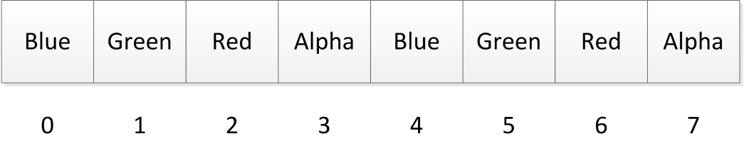

1. The colour of each pixel is given by four successive values in the array. The first three values give the amount of Blue, Green and Red in the pixel. The fourth value is the “Alpha” value for that pixel. This gives the “transparency” of the pixel. The larger this value the more it obscures items drawn beneath it. A value of 255 for the Alpha setting means that that the pixel completely hides the pixel below. We could use values from the **colorData** array to set the colour of the first pixel by writing a statement as follows:

bitmap[0] = new Color(colorData[2], // red   
 colorData [1], // green  
 colorData [0], // blue  
 255); // alpha

This statement creates a new **Color** value from the Red, Green and Blue components of the camera image and stores it in the bitmap. It sets the alpha value of the pixel to 255. Note how the subscripts applied to the **colorData** array fetch the correct colour values. We could add the above statement to the event handler but this would only work for the first pixel in the image. To process the entire image we need a loop. Add this code to the method:

int sourceOffset = 0;  
  
for (int i = 0; i < bitmap.Length; i++)  
{  
 bitmap[i] = new Color(colorData[sourceOffset + 2],  
 colorData[sourceOffset + 1],  
 colorData[sourceOffset],   
 255);  
 sourceOffset += 4;  
}

This loop works down the bitmap setting the colour of each pixel to the next pixel in the **colorData** array. The variable **sourceOffset** is moved down to the start of each four byte sequence of colour values.

1. The final part of the program is to set the bitmap array to be the image on the video texture.

kinectVideoTexture.SetData(bitmap);

This texture will be drawn and show the camera image on the game screen.

If you have followed all this correctly the method should look as follows:

void myKinect_ColorFrameReady(object sender,  
 ColorImageFrameReadyEventArgs e)  
{  
 using (ColorImageFrame colorFrame = e.OpenColorImageFrame())  
 {  
 if (colorFrame == null)  
 return;  
  
 if (colorData == null)  
 colorData = new byte[colorFrame.Width *   
 colorFrame.Height * 4];  
  
 colorFrame.CopyPixelDataTo(colorData);  
  
 kinectVideoTexture = new Texture2D(GraphicsDevice,  
 colorFrame.Width,   
 colorFrame.Height);  
  
 Color[] bitmap = new Color[colorFrame.Width *  
 colorFrame.Height];  
  
 int sourceOffset = 0;  
  
 for (int i = 0; i < bitmap.Length; i++)  
 {  
 bitmap[i] = new Color( colorData[sourceOffset + 2],  
 colorData[sourceOffset + 1],   
 colorData[sourceOffset],   
 255);  
 sourceOffset += 4;  
 }  
  
 kinectVideoTexture.SetData(bitmap);  
 }  
}

### Adjusting the Camera Angle

The Kinect sensor stand contains a small electric motor that can be used to adjust the angle of view of the camera. Our programs can use this motor to line the camera up with the viewing area.

myKinect.ElevationAngle += 5;

This makes the Kinect camera look up by 5 degrees. We can use this in our programs to allow the user to line the camera up on the scene in front of it.

The solution in *Demo 2.1 Kinect Video* implements a video camera using the code we have just written. Make sure before you run it that the video camera is connected. If you press U on the keyboard (or button Y on the gamepad) the elevation of the camera is lifted up. If you press D on the keyboard (or button A on gamepad) the elevation goes down. If you do this too much the motor drive will time out.

### Displaying Errors in XNA programs

The present version of the Kinect XNA program does not display any errors when something goes wrong. Normally an XNA game program will just work. If it has been built correctly the number of things that can go wrong when it runs is very small. However, when a program starts using external hardware such as Kinect sensor bars this introduces a much greater possibility of errors occurring. Here are a few that the program will have to deal with:

* The Kinect sensor bar might not be plugged in
* The Kinect sensor bar might be plugged in to the computer but the sensor bar power supply might be disconnected
* The Kinect sensor might be in use by another program

It is very likely that these problems might arise, and so our game must respond sensibly. The Kinect runtime will throw exceptions if it is unable to perform a task and so a program could catch these exceptions and display a message.

Unfortunately, in an XNA program it is not easy to just display text. Unlike Windows Presentation Foundation (WPF) which has a MessageBox which can be used to display warning messages there is no such mechanism in XNA. We have to build one ourselves.

1. The first thing we need to do is add a **SpriteFont** to the resources in the XNA game. This will be used to display the status messages. Right click the on the **KinectCamContent** project in solution explorer and select **Add** from the context menu that appears. Then select **New Item** as shown below.

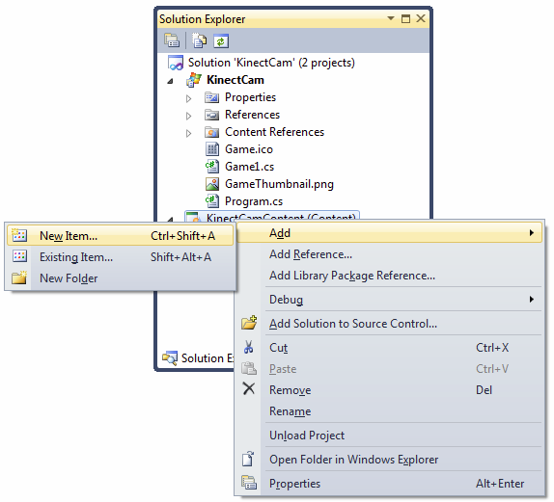

1. From the **Add New Item** dialog select **SpriteFont** and give the name **MessageFont**, as shown below.

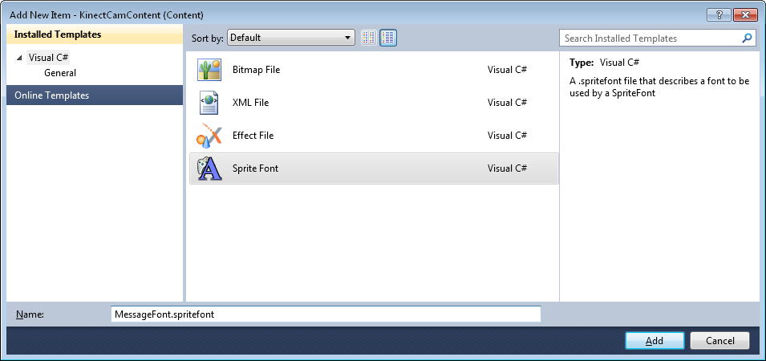

1. When you click **Add** the new font resource will be added to the resources for the game. The font resource will appear in the references for the game, as shown below.

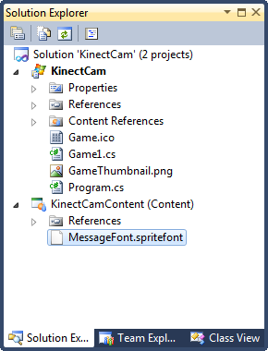

1. Now that we have our font in the XNA project, the next thing we need to do is create some variables in the game that can use the font. Add the following two variables to the game at the top, right after the declaration of the Kinect textures. The first variable holds the font to be used to display the message. The second gives an error message, which is initially an empty string.

SpriteFont messageFont;  
  
string errorMessage = "";

1. Next we need to add some code that will load the font into the game when it starts running. This is performed in the **LoadContent** method, so add the following line to that method:

messageFont = Content.Load<SpriteFont>("MessageFont");

1. Now we have our font we can use it to display message. The messages will be displayed in the **Draw** method. The idea is that if the program encounters an error it can put an error description in the **errorMessage** string. If this string contains text the **Draw** method will display it. Add the following lines to the **Draw** method just before the call of **spriteBatch.End()**.

if (errorMessage.Length > 0)  
{  
 spriteBatch.DrawString(messageFont, errorMessage,  
 Vector2.Zero, Color.White);  
}

We now have an error reporting mechanism. If anything goes wrong the program just has to set the variable errorMessage to a string describing the problem and it will be displayed on the screen by the game.

### Creating a Kinect Setup Method

Rather than doing all the Kinect setup in the LoadContent method it makes sense to create a separate method that sets up the Kinect and handles any errors that may arise. The errors are signalled by exceptions that are thrown by the Kinect methods.

protected bool setupKinect()  
{  
 if (KinectSensor.KinectSensors.Count == 0)  
 {  
 errorMessage = "No Kinects detected";  
 return false;  
 }  
  
 myKinect = KinectSensor.KinectSensors[0];  
  
 try  
 {  
 myKinect.ColorStream.Enable();  
 }  
 catch  
 {  
 errorMessage = "Kinect initialise failed";  
 return false;  
 }  
  
 myKinect.ColorFrameReady +=   
 new EventHandler<ColorImageFrameReadyEventArgs>  
 (myKinect_ColorFrameReady);  
  
 try  
 {  
 myKinect.Start();  
 }  
 catch  
 {  
 errorMessage = "Camera start failed";  
 return false;  
 }  
  
 return true;  
}

The above method sets up the Kinect. If there are no Kinects available or the setup methods throw exceptions the method sets the value of errorMessage to an appropriate value.

1. Add the above method to your program.
2. Change the **LoadContent** method to call this method rather than set the Kinect up itself.

We should now have a program that will respond sensibly if there are any errors setting up the Kinect. We can (and should) test the program by disconnecting the Kinect sensor and running it.

The solution in *Demo 2.2 Kinect Errors* implements a video camera using the code we have just written. It will display a sensible message in the event of the program having problems with the Kinect sensor.

From now on every program that we write will have this error handling built in.

### XNA Programs and Resources

The programs we have written will display video from the Kinect camera very successfully. However, you might be wondering about the effect on the host computer. The video camera will produce a new frame of data around 30 times a second and when it does this the program above will create a brand-new Texture2D value and Color array. However, my experiments have shown that the XNA environment takes this in its stride very well. Because the .NET environment is provided with garbage collection the discarded textures and colour information are recovered and the program does not seem put much load on the host computer.

### Kinect Pop Art

If there is one thing that we know the XNA is good at, it is manipulating and displaying textures. I thought it might be fun to create a “Pop Art” program that displays multi-coloured pop art versions of the camera output. This is very easy to do.



I created a variable that gives the number of panels across and down the screen:

int noOfPanels = 5;

The value 5 gives the result that you see above. Such is the power of XNA that I’ve found that you can draw hundreds of panels if you wish.

Next I needed some colours for the panels themselves:

Color [] popArtColors = new Color[] {   
 Color.Red, Color.Green, Color.Blue, Color.Yellow,   
 Color.Purple, Color.Orange, Color.Cyan, Color.Magenta};

If you want more colours you can just add them to the array above.

Finally I had to modify the Draw method so that rather than draw a single texture it drew a lot of them.

int panelWidth = GraphicsDevice.Viewport.Width / noOfPanels;  
int panelHeight = GraphicsDevice.Viewport.Height / noOfPanels;

These statements work out the width of each panel on the screen. Note that they use integer calculations for simplicity, but this might cause problems with loss of the fraction part if you use very large numbers of panels.

int colorPos = 0;

Each panel must be drawn with a different colour. The variable colorPos holds the position in the popArtColors array which will be used to draw each panel. After each draw the variable is moved on to the next colour in the array.

for (int x = 0; x < noOfPanels; x++)   
{  
 for (int y = 0; y < noOfPanels; y++)  
 {  
 Rectangle destRectangle = new Rectangle(  
 x*panelWidth, y*panelHeight,  
 panelWidth, panelHeight);  
  
 spriteBatch.Draw(kinectVideoTexture, destRectangle,  
 null, popArtColors[colorPos]);  
 colorPos++;  
 if (colorPos == popArtColors.Length) colorPos = 0;  
 }  
}

This is the loop construction that draws the panels on the screen. It uses a slightly more complex version of the SpriteBatch.Draw method than the one we used before. This method can be given source and destination rectangles for the draw operation. We can give the source rectangle as null, which means the entire area of kinectVideoTexture received from the camera. The destination rectangle is created each time from the panel width and height required.

The solution in *Demo 2.3 Pop Art* implements a pop art video camera using the code above. You can change the number of panels that are displayed by modifying noOfPanels and you can add extra colours by changing the content of popArtColors

#### Developing the Pop Art theme

There are versions of the SpriteBatch.Draw method that can rotate textures. You can also “zoom into” a texture by adjusting the position of the source rectangle for a draw action. By creating camera images that are transparent you can also overlay images to get some really amazing effects.

You can also stretch and squeeze the images before they are drawn. In fact the program presently does this, as the aspect ratio of the images that are drawn is that of the display viewport and not the Kinect camera, leading to the images being horizontally distorted.

## Using the Kinect Depth Camera

The Kinect depth sensor is used in a very similar way to the video camera. It produces an “image” which contains depth information for each pixel, rather than the colour of that pixel. The distance readings are given in millimetres and the sensor uses 13 bits to represent each value. This means that the Kinect depth sensor can register objects up to 4 meters from the sensor (4,096 mm). It is not possible to measure the distance of objects closer than 800mm to the Kinect for Xbox sensor and 400mm from the Kinect for Windows sensor. This is because at short distances the infra-red camera that is used cannot focus on individual dots in the grid, just like your eye can’t focus on things held very close to it. In tests I’ve found that I can get good distance results between 1 and 3 meters from the sensor.

All the distance measurement takes place inside the Kinect sensor bar, in other words a program in the computer that uses the distance information just has to process the incoming frames of depth data that the Kinect produces. The depth information is provided as an “image” where each pixel contains a distance value rather than a colour.

As far as the program is concerned there is very little difference between a video image that contains a set data that defines the colour each point in the scene and a “depth image” that contains the distance from each pixel in the scene to a physical object that has reflected the signal from the infra-red camera.

### Setting up the depth camera

To use the depth sensor a program just has to configure the Kinect runtime to produce depth images instead of video ones.

// Get the first Kinect on the computer  
myKinect = KinectSensor.KinectSensors[0];  
  
myKinect.DepthStream.Enable();

In the previous program the ColorStream was enabled. The statement above just selects the depth camera. If we want to use both cameras we just have to enable both streams:

myKinect.DepthStream.Enable();  
myKinect.ColorStream.Enable();

The Kinect for Windows SDK can generate colour, depth and skeleton information at the same time as required. The mechanism for receiving depth images is exactly the same as that for colour images; a program can bind to an event that is fired when a new depth frame is ready:

myKinect.DepthFrameReady +=  
 new EventHandler<DepthImageFrameReadyEventArgs>  
 (myKinect_DepthFrameReady);

The program can connect a method to an event handler which is called each time the camera has a new depth value to be processed. This works in exactly the same way as the video camera.

Finally the program just has to start the depth camera running and producing these events:

myKinect.Start();

### Processing the Depth information

Just as with the video sensor, when the depth sensor receives a new value it will call the event hander to deal with it.

void myKinect_DepthFrameReady(object sender,  
 DepthImageFrameReadyEventArgs e)  
{  
 // create a texture from the depth data  
}

The event handler for the video camera simply took the image information and made coloured pixels for display. For the depth information we are going to write code that will convert the depth values into a greyscale (black and white) image. The further away from the sensor that a pixel is, the darker that pixel will be drawn. To do this the program will have to use the depth data to create the colour values.

This is called a *visualisation* of the depth data. Human beings don’t have eyes that can “see” depth, but we can make a picture that allows us to make sense of the depth data.

### Understanding the depth information

The depth camera produces “images” in the same way as the video camera we have already seen. Our program is given an array of 16 bit values that describe the distance to each point in the scene in front of the depth camera.

The C# short type is used by the Kinect for Windows SDK to hold each 16 bit depth value. A program can obtain the depth value frame data in exactly the same way as it obtains frame information from the video camera.

if ( depthData == null)  
 depthData = new short[depthFrame.Width * depthFrame.Height];  
  
depthFrame.CopyPixelDataTo(depthData);

These two statements create a depthData array and then copy the depth values into it from the depth frame. Each 16 bit value in the depthData array holds a combination of depth and player number information. The depth value is the distance from the depth sensor of that point in the scene. The player number gives the number of that player as detected by the Kinect skeleton tracking. At the moment we are not going to use the player number information, so we have to remove this from the depth value.



The figure above shows how the two pieces of information are fitted together inside a single depth value. The bottom three bits (bit 0 to bit 2) hold the player number. The remaining thirteen (bit 3 to bit 15) hold the distance value. To remove the player information a program can shift the depth value three bits to the right.

int depth = depthData[i] >> 3;

The above statement creates a depth value which is taken from an element in the depthData array. The depth value is shifted right three bits. This causes the player data to “fall off the end” of the value leaving just a thirteen bit depth value.



The diagram above shows what happens after the shift. The top three bits are set to zero when the shift is performed, leaving a 13 bit depth value which can be displayed.

### Creating colour that represents depth

The program can provide a “visualisation” of this depth information. This is like taking a “picture” with the depth camera. To do this we will have to convert all the depth values into colours that can be displayed on the screen. The approach that we are going to use is to convert the depth value into a brightness level. The closer an object is to the screen the brighter it will appear. This should appear as if the sensor is shining a light onto the scene. A program can create a grey colour by setting the red, green and blue values in colour to the same value.

Because the intensity of each colour is set using an 8 bit value and the depth information is a 13 bit value, the program must 5 bits of the value by shifting the depthValue to the right 5 places. This causes the bottom five bits to “drop off” the end of the data value and be discarded. The other thing that the code needs to do is make the parts of the picture that are further away appear darker, rather than lighter. This can be achieved by subtracting the depth value from 255.

byte depthByte = (byte)(255 - (depthValue >> 5));

The above statement performs both of these actions and generates a byte value which represents the depth value as an 8 bit value that is larger when the point is close to the sensor and smaller when it is further away.

#### Special Depth Values

Some depth values are special, in that they don’t describe depth information. Instead they indicate that for a particular reading in the depth values it was not possible to obtain the depth value of that pixel. The three possible indicator values are provided as properties of the DepthStream on the Kinect sensor:

UnknownDepth the depth value could not be determined. This is because that pixel is in shadow or did not reflect a depth value.

TooFarDepth the depth of this point in the scene is beyond the range of the sensor

TooNearDepth the depth value of this point in the scene is too close to the sensor

When our program displays the depth information it could display these parts of the scene in particular colours.

### Displaying the Depth Information

A program can use the depth information to detect objects in a scene. If we want to use all the depth values we have to make a loop that works through the depthData array and works out the colour of each point in the scene.

Color[] bitmap = new Color[depthFrame.Width * depthFrame.Height];  
  
for (int i = 0; i < bitmap.Length; i++)  
{  
 int depth = depthData[i] >> 3;  
 if (depth == myKinect.DepthStream.UnknownDepth)  
 bitmap[i] = Color.Red;  
 else  
 if (depth == myKinect.DepthStream.TooFarDepth)  
 bitmap[i] = Color.Blue;  
 else  
 if (depth == myKinect.DepthStream.TooNearDepth)  
 bitmap[i] = Color.Green;  
 else  
 {  
 byte depthByte = (byte)(255 - (depth >> 5));  
 bitmap[i] = new Color(depthByte, depthByte,   
 depthByte, 255);  
 }  
}

This loop is very similar to the one that calculated the colour the camera pixels in the previous section. However, instead of creating a colour value from the amount of red, green and blue in the camera data this code creates a colour from the depth information. The colour value is a “grey scale” representation of the depth value. A program can create a grey colour by setting the red, green and blue values of the pixel to the same value. In the code above this value is set into the variable depthByte.

The first statement in the loop shifts the raw 16 bit depth value to move the 13 bits of depth information into the right place. Then the code checks for invalid depth values and selects the appropriate colours (red for unknown depth, blue for too far depth and green for too near). If the depth reading is a valid one it is converted into a grey scale image.

This is the statement in the above code that does all this work. A complete myKinect_DepthFrameReady method is shown below.

void myKinect_DepthFrameReady(object sender,  
 DepthImageFrameReadyEventArgs e)  
{  
 using (DepthImageFrame depthFrame = e.OpenDepthImageFrame())  
 {  
 if (depthFrame == null) return;  
  
 if (depthData == null)  
 depthData = new short[depthFrame.Width *   
 depthFrame.Height];  
  
 depthFrame.CopyPixelDataTo(depthData);  
  
 Color[] bitmap = new Color[depthFrame.Width *   
 depthFrame.Height];  
  
 for (int i = 0; i < bitmap.Length; i++)  
 {  
 int depth = depthData[i] >> 3;  
 if (depth == myKinect.DepthStream.UnknownDepth)  
 bitmap[i] = Color.Red;  
 else  
 if (depth == myKinect.DepthStream.TooFarDepth)  
 bitmap[i] = Color.Blue;  
 else  
 if (depth == myKinect.DepthStream.TooNearDepth)  
 bitmap[i] = Color.Green;  
 else  
 {  
 byte depthByte = (byte)(255-(depth >> 5));  
 bitmap[i] = new Color(depthByte, depthByte,   
 depthByte, 255);  
 }  
 }  
  
 kinectDepthTexture = new Texture2D(GraphicsDevice,   
 depthFrame.Width, depthFrame.Height);  
 kinectDepthTexture.SetData(bitmap);  
 }  
}

It is interesting to compare this method with the one that processes the video frames. The fundamental behaviours are the same; it is just that the source of the colour data has a different format.

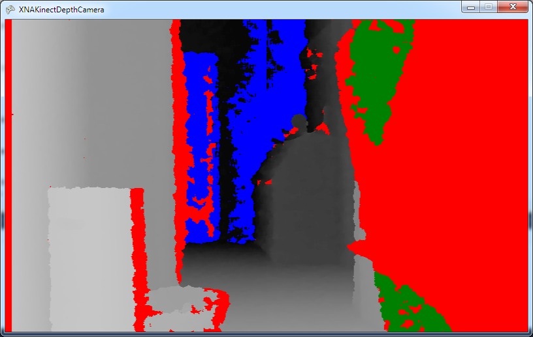 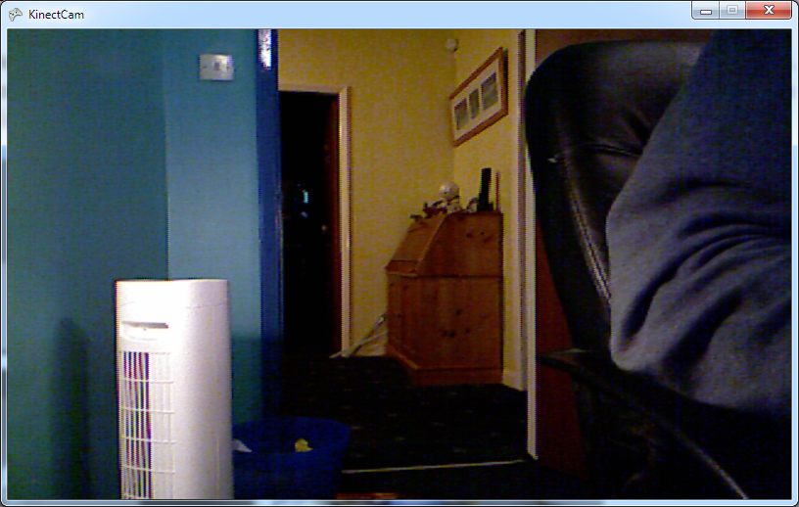

On the left you can see the “depth view” of my rather untidy workplace. On the right you can see the normal video image of the same scene. The Kinect sensor has coloured red all the areas it can’t read the depth of, including my arm which is very close to the sensor. The back of my chair has been coloured green to indicate that it is too close. The fan and waste basket are picked out by the depth sensor, and the far wall is marked as being too distant.

Note that you can get slightly better depth information by treating the depth information as a 12 bit value and ignoring the highest bit.

The solution in *Demo 2.4 Depth Camera* implements the depth camera using the code above.

### Processing the Depth Image

A program can use the depth image for more than just displaying a depth picture. For example a game could use it to get input from a player. The idea is that the player will stand in front of the sensor and point their finger at the Kinect sensor to control a cursor on the screen. The principle is very simple. If the player is in an empty area, and they point at the screen with their finger, the tip of their finger will be the closest thing to the screen. All a program has to do is find the position of smallest depth value in the depth image and that will give the position of the game cursor.

We can start by making a Kinect viewer that displays all the pixels closest to the sensor, i.e. the cursor area, in red. The first thing the program must do is find out the closest position to the sensor.

if ( depthBytes==null)  
 depthBytes = new byte[depthFrame.Width * depthFrame.Height];  
  
for (int i = 0; i < depthData.Length; i++)  
{  
 int depth = depthData[i] >> 3;  
 if (depth == myKinect.DepthStream.UnknownDepth ||  
 depth == myKinect.DepthStream.TooFarDepth ||  
 depth == myKinect.DepthStream.TooNearDepth)  
 {  
 // Mark as an invalid value  
 depthBytes[i] = 255;  
 }  
 else  
 {  
 byte depthByte = (byte)(depth >> 4);  
 depthBytes[i] = depthByte;  
  
 if (depthByte < closestByte)  
 closestByte = depthByte;  
 }  
}

This code is very like the previous loop that worked through the depth array and created the colours to be displayed by the game. However, this code does not create colour values; instead it stores the 8 bit depth values that it calculates. Each value is stored in an array called depthBytes. The bytes are stored because they will be used later in the method to generate the colour values for the display, and it seems silly to re-calculate them again. The test to determine the position closest to the sensor is as follows:

if (depthByte < closestByte)  
{  
 closestByte = depthByte;  
}

Before this test is performed the program makes sure that any invalid values are converted into the largest possible depth, 255. If the depth value is less than the previously detected smallest value, then the program stores that value as the new smallest.

Once the program has found the smallest distance value it can then make a pass through the depthBytes array and generate the pixels for the display:

Color[] bitmap = new Color[depthFrame.Width * depthFrame.Height];  
  
for (int i = 0; i < depthBytes.Length; i++)  
{  
 byte colorValue = (byte)(255 - depthBytes[i]);  
  
 if ( depthBytes [i] == closestByte )   
 bitmap[i] = new Color(colorValue, 0, 0, 255);  
 else  
 bitmap[i] = new Color(colorValue, colorValue,   
 colorValue, 255);  
}  
  
kinectDepthTexture = new Texture2D(GraphicsDevice,   
 depthFrame.Width, depthFrame.Height);  
kinectDepthTexture.SetData(bitmap);

This code only sets the red value of the closest pixels, leaving their green and blue values as zero. This makes those pixels appear red on the screen. The code above converts the depth value (which gets larger the further you are from the sensor) to a brightness value (which gets larger the closer you are to the sensor). It does this by subtracting the depth value from 255.

The solution in *Demo 2.5 Closest Object Highlight* will highlight the parts of a scene that are closest to the camera. If you put the camera in a clear area you can make your finger into the pointer and use it to move the highlighted area around the screen.

### Noise and Resolution

You may be wondering why quite large areas of a scene are highlighted as being closest to the camera. You know that the depth sensor provides values with a precision of 1 millimetre and it seems surprising that such large parts of the screen are exactly that distance away. You can see the explanation in the statement that the program does to convert the 12 bit value into an 8 bit one.

byte depthByte = (byte)(depthValue >> 4);

This removes four bits of resolution, and means that a change of 1 in the value of the depth actually means a change in depth of 16 millimetres. This reduction in resolution is actually quite useful. You can see when you watch the screen that there is quite a bit of noise in the picture that you see. The edges of the objects seem to jitter slightly. If our program just used the location of the closest point in any distance frame this would jump about rather a lot. By reducing the resolution we get values that are a bit less noisy. Of course the problem is that our program needs to find the closest point, and we now have lots of them.

### Calculating a cursor position

The program above will give us a set of points that are closest to the sensor. The next thing to do is take the points and work out a cursor position that they represent.



The diagram above shows what we are trying to do. The shaded blob is the collection of distance values that are closest to the sensor (perhaps a reading from the tip of your finger), what we want to do is work out the position of the centre of this shaded blob.

One way to do this is by working out the average of all the positions. If the shape is broadly symmetrical this should be somewhere in the middle of the blob. Note that this is not a perfect solution, but it is a good start. One of the rules when making programs to decode data this is that you do something simple and see if it works. If it doesn’t behave how you would like, that is when you add complication.

An average is worked out by totalling up all the values and then dividing by the number of values. To work out the coordinate averages a program needs to know the sum of all the X values, the sum all the Y values and the number of values that there are.

int closestXTotal = 0;  
int closestYTotal = 0;  
int closestCount = 0;

These are the three variables we are going to use. Now we have to find out how we are going to calculate them.

for (int i = 0; i < depthBytes.Length; i++)  
{  
 if (depthBytes[i] == closestByte)  
 {  
 // this pixel is one of the ones closest to the camera  
 // work out its position and add it to the totals   
 }  
}

Above is the code that the program uses to work through the depth values. Remember that the array depthBytes holds all the depth values and the variable closestByte holds the depth value which is closest to the Kinect sensor. If the program finds a depth value in the array that is for one of the pixels that is closest to the camera it must work out the X and Y position of this pixel and then add it to the total.



The diagram above shows how the depth values are laid out in a grid which is 640 wide and 480 high. However, the depth information that is supplied to the program is a long list of values. The location (300,2) on the grid is actually is location 1580 in the depthBytes array that is received from the sensor. If you look at the diagram you can see how this works, the first 1280 locations in the depthBytes array contain the depth values for the top two lines in the display. We then have to move 300 positions further along the array to get to the required depth value. If we add 1280 to 300 we get 1580.

Our program has to reverse this process. It will know the position of the value in the Bits array, and it must convert this into X and Y values. It turns out that this is quite easy to do. The counter variable i contains the position of the array and these two statements will get the values of X and Y that a particular value of i represents.

int X = i % image.Width;  
int Y = i / image.Width;

The % (modulus) operator means “the remainder after a division”. If you divide 1580 by 640 and take the remainder you get 300, which is the X value you want. If you divide 1580 by 640 and just use the integer result (which is what C# integer division will do for you) the result is 2, which is the Y value. The final loop to calculate all the X and Y values is as follows:

for (int i = 0; i < depthBytes.Length; i++)  
{  
 byte colorValue = (byte)(255 - depthBytes[i]);  
 if (depthBytes[i] == closestByte)  
 {  
 // Calculate X and Y  
 int X = i % image.Width;  
 int Y = i / image.Width;  
 // Add these to the total  
 closestXTotal += X;  
 closestYTotal += Y;  
 closestCount++;  
 }  
}

Once the totals have been calculated the program can work out the average X and Y values by dividing the total by the number of values.

// Get the average values  
float closestX = (float)closestXTotal / closestCount;  
float closestY = (float)closestYTotal / closestCount;

These two statements work out the average values for X and Y, so that the program has calculated the coordinates of the cursor position. The program using the cursor may not know the width and height of the screen, and so it makes sense for the program to present the cursor positions as a fraction in the range 0 to 1.

// work out the cursor positions as a fraction of the screen size  
cursorX = closestX / kinectDepthWidth;  
cursorY = closestY / kinectDepthHeight;

These to values can now be used in a program to position an element on the screen.

### Using the cursor position in an XNA program

When the game is running the Kinect camera will be continuously producing new depth frames that can be processed as above to find the position of the cursor. It will set the cursor position into two variables which are part of the XNA game.

float cursorX;  
float cursorY;

These values can be used by the Update method in the game to position a game cursor on the screen.

protected override void Update(GameTime gameTime)  
{  
 // Allows the game to exit  
 if (GamePad.GetState(PlayerIndex.One).Buttons.Back ==  
 ButtonState.Pressed)  
 this.Exit();  
  
 ballRectangle.X =   
 (int)((cursorX * GraphicsDevice.Viewport.Width) -   
 ballRectangle.Width / 2);  
 ballRectangle.Y =   
 (int)((cursorY * GraphicsDevice.Viewport.Height) -   
 ballRectangle.Height / 2);  
  
 base.Update(gameTime);  
}

The Update method above positions a rectangle at the cursor position. It multiplies the cursor position by the screen size and then uses the dimensions of the rectangle so that it is centred about the cursor.

The solution in *Demo 2.6 Finger Cursor* creates a ball cursor which follows the closest object around the screen. You can use this cursor as the basis of a perfectly playable game.

If you really want to use the player as the controller the Kinect SDK will perform skeleton tracking. We will use this in the next section when we create an augmented reality based game. However, it is interesting to see that even very simple code can be used to create useable human controlled systems.

## Using Sound with Kinect

The Kinect sensor bar contains four high quality microphones arranged along its length. These are used in conjunction with Digital Signal Processing (DSP) elements in the sensor to allow the Kinect to “focus” on sound sources. Because sound waves take a measurable time to travel through the air the sound from a particular source will arrive at different types at the four microphones.



The diagram shows how this works. The drum beats will arrive at the microphones across the sensor bar at slightly different times. Clever software in the Kinect can recognise the beats and use the timing information to detect the direction the sound is coming from. It can then filter out sounds coming from other directions.

The main reason for this special hardware is to allow the sensor to produce a very high quality voice signal. This can be used in telephony, so that you can use your Kinect in conversations with other computer users. It can also be used in speech recognition systems where the program decodes speech input and responds to it.

The Kinect sensor can sample sound at the rate of 16,000 samples every second. Each of the samples is a 16 bit value which represents the sound intensity at that particular sample point in time. This data rate is not quite enough for high fidelity sound recording, but is more than adequate for high quality speech.

### The Kinect Parrot Game

We are going to start by creating a program that can capture sound input and play it back. The sound sample values will be stored in an array in the program from which they can be replayed.

#### Program State Management

Like all good games, the Kinect Parrot program is a state machine. At any given instant it is in one of the following states.

enum ParrotState  
{  
 idle,  
 recording,  
 playing  
};  
  
ParrotState state;

The XNA Update method is called 60 times a second. Each time it is called it uses the state of the game to determine which internal method to call.

protected override void Update(GameTime gameTime)  
{  
 // Allows the game to exit  
 if (GamePad.GetState(PlayerIndex.One).Buttons.Back ==   
 ButtonState.Pressed)  
 this.Exit();  
  
 padState = GamePad.GetState(PlayerIndex.One);  
 keyState = Keyboard.GetState();  
  
 switch (state)  
 {  
 case ParrotState.idle:  
 updateIdle();  
 break;  
  
 case ParrotState.recording:  
 updateRecording();  
 break;  
  
 case ParrotState.playing:  
 updatePlayback();  
 break;  
 }  
  
 oldPadState = padState;  
 oldKeyState = keyState;  
  
 base.Update(gameTime);  
}

The initial state of the game is idle. The game will return to this state after each record and playback operation. In the idle state the program will use the gamepad buttons and the keyboard to decide whether to begin recording or play back a sample.

#### Controlling the Program

The updateIdle method is called to update the game when the game is in the idle state, i.e. the program is not doing anything and is waiting for a command to start doing something

void updateIdle()  
{  
 if ((oldPadState.Buttons.A == ButtonState.Released &&  
 padState.Buttons.A == ButtonState.Pressed) ||  
 (oldKeyState.IsKeyUp(Keys.A) && keyState.IsKeyDown(Keys.A)))  
 {  
 startPlayback();  
 }  
  
 if ((oldPadState.Buttons.B == ButtonState.Released &&  
 padState.Buttons.B == ButtonState.Pressed) ||  
 (oldKeyState.IsKeyUp(Keys.B) && keyState.IsKeyDown(Keys.B)))  
 {  
 startRecording();  
 }  
}

It looks for changes in the state of the A and B keys/buttons and calls methods to start recording or playback if a key is pressed. If the user presses the A button the state of the button will change from Released to Pressed. The Update method sets up variables which contain the previous and the current state of the inputs.

#### Capturing and storing sound

Captured sound data can be held in memory or stored in a file. The Kinect parrot program will use a buffer to hold the sound sample in memory. The buffer is just an array of byte values with a particular size.

const int bufferSize = 50000;  
  
byte[] soundSampleBuffer = new byte[bufferSize];

A buffer of 50,000 bytes will store around a second and a half of sound. Remember that a single sample will occupy two bytes of storage since the samples are 16 bit values and byte array holds data in 8 bit sized elements.

The Kinect SDK provides a class called KinectAudioSource that provides access to sound input. An instance of this class is exposed as a property of the KinectSensor class. A program that wants to work with sound from the Kinect can use the AudioSource property of a sensor that it creates. The program can also set properties on the AudioSource value to control the sensor bar audio hardware, although the default settings will work fine for our first program.

The KinectAudioSource class provides a method called Start which will start the sound sampling process and return a stream object that the game can read sound samples from.

Stream kinectAudioStream;  
kinectAudioStream = myKinect.AudioSource.Start();

The Stream class is part of the .NET Input/Output library and is used whenever a program wants to have access to a stream of bytes from a source. Each time the game updates it will read another set of sound samples from the stream, up to the limit of the buffer.

#### Recording audio

When the user presses B the updateStarting method calls the startRecording method.

void startRecording()  
{  
 kinectAudioStream = myKinect.AudioSource.Start();  
 state = ParrotState.recording;  
 message = "Recording";  
}

The method creates a sound source and then uses it to create an audio stream. The state of the game is set to recording and an appropriate message is displayed. Each time the game is updated the updateRecording method is called.

void updateRecording()  
{  
 kinectAudioStream.Read(soundSampleBuffer, 0,   
 soundSampleBuffer.Length);  
 myKinect.AudioSource.Stop();  
 message = "Press A to playback B to record again";  
 state = ParrotState.idle;  
}

The updateRecording method reads the sound sample from the Kinect audio stream into the array. When the sample has been read the method stops the sound source and changes the state back to idle.

Note that this is not very good program design, as the Read operation on the Kinect audio stream will take around three seconds to fill the buffer we are using. This will cause the Update method to pause for around three seconds. Ideally the Update method in an XNA game should complete in around a 60th of a second so that the game display updates smoothly. In this demonstration program this OK but in a proper sound recording program the sound capture would be performed on a separate thread.

#### Playing Back Audio

The XNA framework has very good support for sound effects in games. The SoundEffect class provides a means by which a game can load a sound resource and play it back at the appropriate point in the gameplay. However to play back audio that has been recorded a game must use the DynamicSoundEffect class. This lets a program dynamically create sound waveforms and play them back. This provides the very interesting possibility of a game creating a sound waveform programmatically and it also makes it possible for a game to play back a buffer of recorded sound samples, which is what we are going to use it for.

DynamicSoundEffectInstance playback =   
 new DynamicSoundEffectInstance(16000, AudioChannels.Mono);

The above statement makes a new DynamicSoundEffect instance which will play back a single audio channel which was recorded at the rate of 16,000 samples per second. This matches the sample format produced by the Kinect audio stream.

void startPlayback()  
{  
 playback.SubmitBuffer(soundSampleBuffer);  
 playback.Play();  
 message = "Playing";  
 state = ParrotState.playing;  
}

The startPlayback method calls the method SubmitBuffer on the sound effect. This sends the buffer of recorded samples to the sound effect and then begins playing it. It sets the display to show that a sample is playing and then updates the game state. Each time the game updates it will call the updatePlayback method.

void updatePlayback()  
{  
 if (playback.PendingBufferCount == 0)  
 {  
 message = "Press A to playback B to record again";  
 state = ParrotState.idle;  
 }  
 else  
 {  
 playback.Pitch = padState.ThumbSticks.Left.X;  
 }  
}

The updatePlayback method checks to see if the sound has finished playing. If it has finished (the number of samples left to play is zero) the screen message is updated and the state of the game is set back to idle. This method has an additional little trick, in that it uses the X (left-right) position of the left thumbstick to change the pitch of the playback. This allows you to change the pitch of the sound when it is played back.

The solution in *Demo 2.7 Kinect Parrot* creates a program that can sample sounds and play them back. Press B to record a sample and A to play it back.

## What We Have Learned

1. Access to video and depth cameras are managed by the Kinect Runtime class which can be created and configured by a program that wishes to use the Kinect sensor
2. The video and depth cameras can produce events when they have new information for a program to process.
3. Both video and depth events are supplied with a list of data points. For the colour camera each point is a set of Blue, Green, Red and transparency (Alpha) byte values. For the depth camera each point is a 13 bit distance to an object at that point in the scene. The distance is expressed in mm in the range 80mm to 4M
4. The XNA framework allows a program to create a texture from colour values that can be calculated from depth or colour information.
5. Programs can use the depth information to locate and track objects in the view of the sensor.
6. The Kinect sound input hardware uses four microphones and Digital Signal Processing (DSP) to create good high quality sound signals that can be isolated from their environment.
7. Program can read audio samples as sequences of sound intensity values that can be stored in arrays.
8. The XNA framework provides a dynamic sound effect mechanism by which a program can play back sounds produced from software, including stored sound information that has been previously recorded.

# Kinect Natural User Interfaces

A “Natural User Interface” is one where the user is not really aware that they are interacting with a computer program. The user just does what they would do naturally and the system just works. The Kinect sensor can be used to create natural user interfaces. We can create programs that react directly to user actions and spoken commands.

In this section we will start by finding out how the Kinect sensor can perform body tracking. Then we will move on to create programs that provide voice response.

## People tracking in Kinect

We have seen that the depth sensor provides data about the objects in a scene in front of it. We have also created some simple motion tracking software which allowed a user to implement a screen cursor just by pointing at the Kinect sensor bar. Now we are going to go even further and see how the Kinect SDK makes it possible to track body position.

### Kinect skeleton tracking

The Kinect for Windows SDK contains software that can track the position of people standing in front of the sensor. You have seen how the depth information can be used to locate specific points in a scene; with more advanced software a program can isolate an object from the space around it. If this object is a characteristic shape, for example a human skeleton, the software can then identify parts of that object and their positions.

The skeleton tracking performed by Kinect was developed after a lot of research into the variations in human anatomy. The software has been trained to recognise a depth profile describing a shape which contains the characteristic features of head, arms, body and legs. Because the human skeleton contains a fixed number of joints and provides a specific set of movements for each joint the software in the Kinect SDK can deduce the position of these joints and provide the values to a program running on the connected PC.

It is worth remembering that unlike the raw camera and sound information provided by the sensor, the skeleton tracking is actually performed by software running on your computer. This means that the rate at which the tracking takes place is governed by the speed of your machine. If you want to get tracking information more rapidly, one way is to use a faster computer. However, I’ve found that even on fairly low-specification laptops the skeleton tracking is rapid enough to be useful.

#### Kinect Skeleton Data

The Kinect SDK regards a human skeleton as being made from 19 “bones” which are connected by 20 joints.

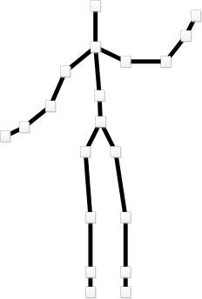

When the Kinect SDK is tracking a figure it will provide the position in 3D space of each of these joints. The Kinect SDK can track two figures at this level of detail. It can also track a further four figures for which it only provides a single piece of position information. A program can draw a stick figure such as the one above by joining particular joints together with lines. The position of each joint is given in three dimensions in the space in front of the sensor.

* How far to the left/right of the sensor (X)
* How far above/below the sensor (X)
* How far away from the sensor (Z)

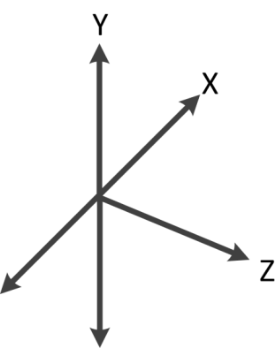

The coordinates are arranged as above. You can think of the Kinect sensor bar as being positioned at the intersection of all the axes on the diagram. The Kinect is facing in the Z direction, in other words if you shone a torch in the same direction as the Kinect is looking it would shine out along the Z axis. The value of X will be the distance to the left (-) or right (+) of the torch beam. The value of Y will be the distance above (+) or below (-) the torch beam and the value of Z will be the distance along the torch beam.

### Using the Kinect SDK skeletal tracking

A program that wants to track the position of people in front of the sensor must select this option when a new Kinect Runtime is created.

myKinect = KinectSensor.KinectSensors[0];  
  
myKinect.SkeletonStream.Enable();  
  
myKinect.Start();

The statements above obtain a KinectSensor value and then request skeleton tracking on that sensor. If a program wants to use skeleton tracking in conjunction with other Kinect sensors it can enable those as well.

### Processing Skeleton Frames

As with the video and depth cameras, the Kinect SDK can create an event each time it has new data for the program.

myKinect.SkeletonFrameReady +=   
 new EventHandler<SkeletonFrameReadyEventArgs>  
 (myKinect_SkeletonFrameReady);

It the Kinect was set up as above the method myKinect_SkeletonFrameReady would run each time the Kinect SDK has some new skeleton position information. This event is created each time the Kinect SDK has completed analysis of a depth frame, it does not mean that there is tracked skeleton data available. If a program wants to use skeleton tracking information it must check that the data is valid before tries to use it.

Skeleton [] skeletons = null;  
  
void myKinect_SkeletonFrameReady(object sender,  
 SkeletonFrameReadyEventArgs e)  
{  
 using (SkeletonFrame frame = e.OpenSkeletonFrame())  
 {  
 if (frame != null)  
 {  
 skeletons = new Skeleton[frame.SkeletonArrayLength];  
 frame.CopySkeletonDataTo(skeletons);  
 }  
 }  
}

Above you can see how the event handler could be used. It follows a very similar pattern to the methods that receive events from the depth and video camera. The arguments to the method include a value of type SkeletonFrameReadyEventArgs which can deliver a SkeletonFrame value which holds the collection of skeletons that are being tracked. The method above copies all the skeleton information into a game variable called skeletons.

It is important to remember that this method is not running as part of the XNA cycle of Draw and Update. Normally an XNA game would update the game state in the Update method and draw the display in the Draw method. However, the event above is produced when the Kinect SDK has new skeleton information. The skeleton information event will not be synchronised with XNA, and so it leaves skeleton information to draw in the skeletons variable for the game to use. In our first program, that just views the skeleton; the Draw method will use the skeleton data in skeletons to just draw the skeletons on the screen.

protected override void Draw(GameTime gameTime)  
{  
 GraphicsDevice.Clear(Color.CornflowerBlue);  
  
 spriteBatch.Begin();  
  
 if ( skeletons != null )  
 foreach ( Skeleton s in skeletons)  
 if (s.TrackingState == SkeletonTrackingState.Tracked)  
 drawSkeleton(s, Color.White);  
  
 spriteBatch.End();  
  
 base.Draw(gameTime);  
}

The version of Draw above checks to see if the skeleton data is valid. If there is skeleton data available the drawSkeleton method is called to draw it. The skeleton information is provided as a collection of Joint values, one for each part of the skeleton.

#### The Joint type

The position of each of the joints in the skeleton will be expressed in a value of type Joint. A Joint value contains a Vector that holds the X, Y and Z position and a status value that denotes how confident the Kinect SDK is about the position of the joint. The status value is expressed as a value of type JointTrackingState:

public enum JointTrackingState  
 {  
 NotTracked = 0,  
 Inferred = 1,  
 Tracked = 2,  
 }

If the Kinect SDK is unable to determine the position of the joint the state is given as NotTracked. If the SDK is confident it has tracked the position of the joint the state is set to Tracked. The third status, Inferred, is returned if the SDK is not tracking the joint, but has inferred the position of the joint based on ones around it that are being tracked. You might see this situation if the user is wearing loose or baggy clothing, or a skirt. In these situations the software will make a “best guess” to work out the position of the joints. If your program needs to know exactly where the joint is it should check for the Tracked state.

### Drawing the skeleton

A skeleton contains a collection of joint information which is indexed on a value of JointType. For example, to get the value of the Joint that defines the position of the head in the active skeleton a program would use the following:

Joint headJoint = activeSkeleton.Joints[JointType.Head];

There are 20 values for JointType, one for each of the joint types in the skeleton. To draw a skeleton the program just has to draw bones between all the joints that make up the body. The drawSkeleton method calls a method to draw each bone in turn, using the colour that has been assigned to this skeleton.

#### Drawing the bones

The drawBone method takes two joints and a colour and draws the bone between them.

drawBone(activeSkeleton.Joints[JointType.Head],  
 activeSkeleton.Joints[JointType.ShoulderCenter],   
 col);

The above statement would call the method to draw the bone that links the head to the joint between the shoulders.

#### Converting Joint positions into 2D coordinates

The position of each joint in the skeleton is supplied as a 3D value, with X, Y and Z components. The XNA Framework is quite capable of manipulating and displaying objects in three dimensions but we want to draw the skeleton using lines on a 2D image.

The Kinect SDK can map skeleton joint positions onto the 2D image produced by the depth camera or the 2D image produced by the video camera. The SDK provides two mapping functions because the depth and video cameras are not in exactly the same position on the sensor bar and so the coordinate values have to be adjusted differently for each camera.

We are going to use the mapping that puts the skeleton positions into the same coordinate space as the video camera. We would use this mapping if you wanted to create “augmented reality”, where a program draws items on top of a video image of the person in the frame. We will be doing this in the next section.

If you want to use the position of the skeleton in relation to readings from the depth sensor you can use the method that maps skeleton positions into the depth frame. It is called MapSkeletonPointToDepth and it works in exactly the same way, producing a DepthImagePoint result.

ColorImagePoint headPos = myKinect.MapSkeletonPointToColor(  
 headJoint.Position,   
 ColorImageFormat.RgbResolution640x480Fps30);

The MapSkeletonPointToColor method is given the position to work on and returns the position as a value of type ColorImagePoint. In the statement above the value of headPos would be set to the position in the colour image of the head joint. The values are given in the range that matches the ColorImageFormat that is specified in the call, in this case an area 640 pixels wide and 480 pixels high.

You should note however that although the format gives the size of the screen to be used, the values are still capable of going outside that range. If part of the player is outside the screen range (for example their head is above the top of the screen) the y value for their head position may become negative.

The ColorImagePoint values can be used to create an XNA vector that can be used to draw the image.

void drawBone(Joint j1, Joint j2, Color col)  
{  
 ColorImagePoint j1P = myKinect.MapSkeletonPointToColor(  
 j1.Position,   
 ColorImageFormat.RgbResolution640x480Fps30);  
 Vector2 j1V = new Vector2(j1P.X, j1P.Y);  
  
 ColorImagePoint j2P = myKinect.MapSkeletonPointToColor(  
 j2.Position,   
 ColorImageFormat.RgbResolution640x480Fps30);  
 Vector2 j2V = new Vector2(j2P.X, j2P.Y);  
  
 drawLine(j1V, j2V, col);  
}

The method drawBone draws the bone between two skeleton joints. It uses the MapSkeletonPointToColor method to get the X and Y positions of the joints and then draws a line between them.

#### Drawing Lines in XNA

The best way to draw a line in XNA is to draw a dot and then stretch and rotate it to look like a line.

Texture2D lineDot;

The texture lineDot holds a tiny white texture which is 4 pixels square. This is stretched and rotated to create a line. The stretching and rotation is performed by the SpriteBatch Draw method.

void drawLine(Vector2 v1, Vector2 v2, Color col)  
{  
 Vector2 diff = v2 - v1;  
 Vector2 scale = new Vector2(1.0f, diff.Length() /   
 lineDot.Height);  
 float angle = (float)(Math.Atan2(diff.Y, diff.X)) -   
 MathHelper.PiOver2;  
 Vector2 origin = new Vector2(0.5f, 0.0f);  
 spriteBatch.Draw(lineDot, v1, null, col, angle, origin,   
 scale, SpriteEffects.None, 1.0f);  
}

The drawLine method above is supplied with two vectors that give the start and the end of the line to be drawn. It creates a new vector, diff, which is the one between the points and then scales and rotates the dot to fit along that vector. The method is also supplied with the colour of the line to be drawn.

### Drawing the complete skeleton

To draw the complete skeleton the joints must be connected by the correct bones.

void drawSkeleton(Skeleton skel, Color col)  
{  
 // Spine  
 drawBone(skel.Joints[JointType.Head], skel.Joints[JointType.ShoulderCenter], col);  
 drawBone(skel.Joints[JointType.ShoulderCenter], skel.Joints[JointType.Spine], col);  
  
 // Left leg  
 drawBone(skel.Joints[JointType.Spine], skel.Joints[JointType.HipCenter], col);  
 drawBone(skel.Joints[JointType.HipCenter], skel.Joints[JointType.HipLeft], col);  
 drawBone(skel.Joints[JointType.HipLeft], skel.Joints[JointType.KneeLeft], col);  
 drawBone(skel.Joints[JointType.KneeLeft], skel.Joints[JointType.AnkleLeft], col);  
 drawBone(skel.Joints[JointType.AnkleLeft], skel.Joints[JointType.FootLeft], col);  
  
 // Right leg  
 drawBone(skel.Joints[JointType.HipCenter], skel.Joints[JointType.HipRight], col);  
 drawBone(skel.Joints[JointType.HipRight], skel.Joints[JointType.KneeRight], col);  
 drawBone(skel.Joints[JointType.KneeRight], skel.Joints[JointType.AnkleRight], col);  
 drawBone(skel.Joints[JointType.AnkleRight], skel.Joints[JointType.FootRight], col);  
  
 // Left arm  
 drawBone(skel.Joints[JointType.ShoulderCenter], skel.Joints[JointType.ShoulderLeft], col);  
 drawBone(skel.Joints[JointType.ShoulderLeft], skel.Joints[JointType.ElbowLeft], col);  
 drawBone(skel.Joints[JointType.ElbowLeft], skel.Joints[JointType.WristLeft], col);  
 drawBone(skel.Joints[JointType.WristLeft], skel.Joints[JointType.HandLeft], col);  
  
 // Right arm  
 drawBone(skel.Joints[JointType.ShoulderCenter], skel.Joints[JointType.ShoulderRight], col);  
 drawBone(skel.Joints[JointType.ShoulderRight], skel.Joints[JointType.ElbowRight], col);  
 drawBone(skel.Joints[JointType.ElbowRight], skel.Joints[JointType.WristRight], col);  
 drawBone(skel.Joints[JointType.WristRight], skel.Joints[JointType.HandRight], col);  
}

This method performs the draw action for each of the bones, connecting them together to draw a skeleton figure.

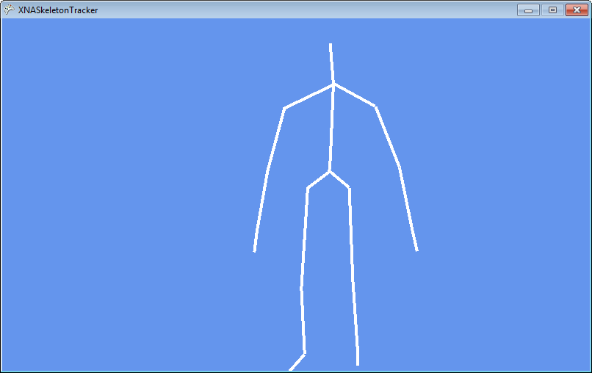

Above you can see the output of the code.

The solution in *Demo 2.8 Skeleton Display* creates a program that displays the skeleton of a person standing in front of the Kinect sensor. The draw positions are registered on the colour camera. This means that if the skeleton was draw on top of the video image the lines would correspond to the bones in the figure.

## Creating Augmented Reality

Augmented reality is a process by which data from the real world (for example video and object positions) are mixed with computer generated objects to produce something which is a combination of both worlds. The Kinect is a very useful tool for working with augmented reality as it provides high quality information about the world around it. We are going to create an augmented reality game which combines video of the player with computer generated elements. The Kinect sensor will be used to obtain the player image and use the depth sensor to register the position of the player inside the game.

### Cloud Burster

We now know how to get skeleton information about a player of a game. The next thing to do is to put the player into a game world. We are going to create an augmented reality game called “Cloud Burster” which puts the player in the role of a vengeful giant who has a thing about clouds flying over his badly drawn terrain and uses the red pin of evil to burst them. The player will be drawn inside the game world alongside the game sprites and the background.

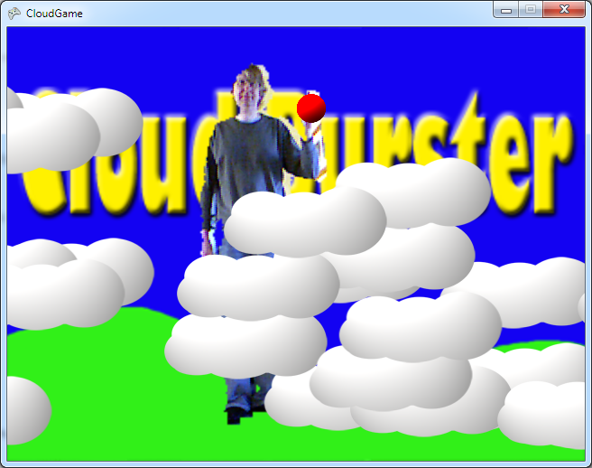

Above you can see the game in play, with the giant bursting the clouds as they fly in from the left of the screen.

### Creating the Cloud sprite display

All the clouds are based on a single cloud design. Each cloud sprite in the game has its own texture reference however, so you could replace my single boring sprite design with more if you wish.



The clouds are implemented by a Cloud class which provides simple sprite behaviours. The game has been designed so that other sprites can easily be added later.

interface ISprite  
{  
 void Draw(CloudGame game);  
 void Update(CloudGame game);  
}

Any sprite that implements the ISprite interface can be used as a sprite in this game. The Draw and Update methods in the class are passed a reference to the game they are part of so that they can interact with it. For example a cloud sprite can check the position of the pin in the game so that it can detect when it has been burst. It could call a method to update the game score at when this happened.

class Cloud : CloudGame.ISprite  
{  
 public Texture2D CloudTexture;  
 public Vector2 CloudPosition;  
 public Vector2 CloudSpeed;  
 public bool Burst = false;  
 public SoundEffect CloudPopSound;  
  
 static Random rand = new Random();  
  
 ...Draw and Update behaviours here  
}

The Cloud class contains texture, position and speed properties, along with status information and a sound effect to play if it is popped.

public void Draw(CloudGame game)  
{  
 if (!Burst)  
 game.spriteBatch.Draw(CloudTexture, CloudPosition,  
 Color.White);  
}

The Draw method draws the cloud if it has not been burst by the vengeful giant.

public void Update(CloudGame game)  
{  
 if (Burst) return;  
  
 CloudPosition += CloudSpeed;  
  
 if (CloudPosition.X > game.GraphicsDevice.Viewport.Width)  
 {  
 CloudPosition.X = -CloudTexture.Width;  
 CloudPosition.Y = rand.Next(  
 game.GraphicsDevice.Viewport.Height  
 - CloudTexture.Height);  
 }  
  
 if (CloudContains(game.PinVector))  
 {  
 CloudPopSound.Play();  
 Burst = true;  
 return;  
 }  
}

The Update method moves the cloud along the screen at the speed of that cloud. If the cloud goes off the right hand edge of the screen it is placed back on the left hand edge at a random height. The variable PinVector is a public member of the CloudGame class and gives the position of the pin being held by the player. If the pin is inside the cloud the pop sound for that cloud is played and the burst status is set to true, so that the cloud is no longer drawn.

public bool CloudContains(Vector2 pos)  
{  
 if (pos.X < CloudPosition.X)   
 return false;  
 if (pos.X > (CloudPosition.X + CloudTexture.Width))   
 return false;  
 if (pos.Y < CloudPosition.Y)   
 return false;  
 if (pos.Y > (CloudPosition.Y + CloudTexture.Height))   
 return false;  
 return true;  
}

The CloudContains method provides collision detection for the cloud. If the position of the pin is within the area of the screen occupied by the cloud the method returns true. Of course the natural enemy of the cloud is the pin, and so next we need to consider how the pin will be displayed.

The Draw and Update methods implement a drifting cloud that works well. You could easily add some extra code to allow a cloud to drift in different directions. You could also extend the Cloud class to provide clouds with slightly different behaviours, perhaps some which chase the player.

#### Storing 100 clouds in the game

All the clouds are held in a list of sprites used by the game.

List<ISprite> gameSprites = new List<ISprite>();

When the game starts it creates 100 clouds and adds them to a list of game sprites.

for (int i = 0; i < noOfSprites; i++)  
{  
 Vector2 position =  
 new Vector2(rand.Next(GraphicsDevice.Viewport.Width),  
 rand.Next(GraphicsDevice.Viewport.Height));  
  
 // Parallax scrolling of clouds  
 Vector2 speed = new Vector2(i / 6f, 0);  
  
 Cloud c = new Cloud(cloudTexture, position, speed, cloudPop);  
  
 gameSprites.Add(c);  
}

The speed of the cloud movement is managed so that clouds which are “closer”, i.e. drawn last; move slightly faster. This is called “parallax scrolling” and gives an impression of depth.

The Draw and Update methods in the game work through the list of clouds and update and draw them as appropriate.

foreach (ISprite sprite in gameSprites)  
 sprite.Draw(this);

This is the behaviour in the Draw method. If you need a way to create and manage game objects in an XNA game this is a good start. You could create different kinds of clouds, perhaps ones that moved differently or require several attempts to pop, and as long as they implement the ISprite interface they can be used in the game.



This shows what the clouds look like as they move across the screen. The next thing that is required is a game picture to put behind the clouds and the drawing of the vengeful giant with pin.

### Building the display using layers

The display of the game will be implemented by drawing a series of layers, each of which will be a different texture. XNA draws things on the screen in the order that they are drawn by the program. The clouds at the “front” of the image above appear to obscure the clouds behind because the more distant clouds were drawn first. Our game wants to display the player inside the game environment, as we saw in the image at the start of this section. This will be achieved by doing the following in this order:

1. Draw the image from the video camera. This will show the whole of the scene that the Kinect is viewing, including the image of the player.
2. Draw the landscape background. Parts of the background will be made transparent so that the player shows through from the image “below”. The Kinect can provide depth and player information that allows a program to work out which areas of a depth image are occupied by a player.
3. Draw the pin. This is a round texture which is drawn over the right hand of the player. The pin draw rectangle is positioned using the skeleton information.
4. Draw the clouds. This will initially be on top of the player, as the player bursts more and more clouds you will see more of them.

The Draw method below shows how this works. Each of the images is a texture which is drawn on top of the next one.

protected override void Draw(GameTime gameTime)  
{  
 GraphicsDevice.Clear(Color.CornflowerBlue);  
  
 spriteBatch.Begin();  
  
 spriteBatch.Draw(kinectVideoTexture, fullScreenRectangle,  
 Color.White);  
 spriteBatch.Draw(gameMaskTexture, fullScreenRectangle,   
 Color.White);  
  
 foreach (ISprite sprite in gameSprites)  
 sprite.Draw(this);  
  
 spriteBatch.Draw(pinTexture, pinRectangle, Color.Red);  
  
 spriteBatch.End();  
  
 base.Draw(gameTime);  
}

Note that this means the game does not isolate the image of the player against the background. Instead it cuts a “hole” through an image and lets the parts containing the player show through. This technique works well, and means that the resolution of the mask image and the background image can be different.

### Getting Depth and Player information from Kinect

So, now we need to know how to get the Kinect sensor to tell the program which parts of the scene in front of it are game players and which are furniture.

myKinect = KinectSensor.KinectSensors[0];  
myKinect.SkeletonStream.Enable();  
myKinect.ColorStream.Enable();  
myKinect.DepthStream.Enable(  
 DepthImageFormat.Resolution320x240Fps30);  
myKinect.Start();

Above you can see the initialisation of the KinectSensor used in the cloud game. The skeletal tracking is used so that the game can find the pin that is bursting balloons. The colour camera is used to obtain a view of the player and final option asks the sensor to produce both depth and player index information about each player. The Kinect sensor SDK is quite happy to produce output from all three sensors simultaneously.

#### Image resolution and performance

When the program enables a colour stream or a depth stream it can use the default resolution (640x480) or it can select a different format. In the above setup code you will notice that the program sets the resolution of the depth stream to a lower resolution of 320x240. This is because the program will be doing a lot of work with the depth image pixels. It will be working through each depth image reading and using it as a mask onto the video image. A 640x480 pixel image has four times the number of pixels of one which is 320x240 in size. We can therefore greatly reduce the amount of work the program has to do by using less depth data.

The effect of this that the high resolution video image will be masked by an image that has lower resolution. XNA is perfectly capable of performing the image scaling to do this.

#### Receiving events

Up until now we have create programs that contain event handlers that run when a particular data source in the Kinect SDK has new data. We could use these events in our augmented reality game but the program would have to work out when all the required data was available. To draw a frame the program needs to have a video image, skeleton and depth image and it would be much easier to just have a single event triggered when all of the data sources had information ready. Fortunately the Kinect SDK can do this for us:

myKinect.AllFramesReady +=   
 new EventHandler<AllFramesReadyEventArgs>(myKinect_AllFramesReady);

The event handler myKinect_AllFramesReady will run when all the data is available for the game to use.

### Creating the textures

When new depth information is available the game will do the following things:

1. Create a texture from the video image from the colour camera. This includes the player.
2. Find the currently active skeleton, i.e. the skeleton information that represents the current player of the game.
3. Make a mask texture which is the game “background”, in this case the tasteful “Cloud Burster” screen you see above.
4. Work through the depth data looking for pixels in the depth data that match the current player. When the method finds such a pixel it must map the position of that pixel into the mask texture and make the corresponding mask pixel transparent so that the player image shows through.

#### Creating a Texture from the Video Image

The code that gets the video texture is exactly the same as the code that we used before, when we just displayed the video image from the colour camera.

using (ColorImageFrame colorFrame = e.OpenColorImageFrame())  
{  
 if (colorFrame == null)  
 return;  
  
 if (colorData == null)  
 colorData = new byte[colorFrame.Width *   
 colorFrame.Height * 4];  
  
 colorFrame.CopyPixelDataTo(colorData);  
  
 kinectVideoTexture = new Texture2D(GraphicsDevice,   
 colorFrame.Width,  
 colorFrame.Height);  
  
 Color[] bitmap = new Color[colorFrame.Width *   
 colorFrame.Height];  
  
 int sourceOffset = 0;  
  
 for (int i = 0; i < bitmap.Length; i++)  
 {  
 bitmap[i] = new Color(colorData[sourceOffset + 2],  
 colorData[sourceOffset + 1],   
 colorData[sourceOffset], 255);  
 sourceOffset += 4;  
 }  
  
 kinectVideoTexture.SetData(bitmap);  
}

The method builds a new texture called kinectVideoTexture that holds the current display image. This image will be drawn first.

#### Finding the currently active skeleton

The Kinect sensor can track up to 6 bodies, but only two of those will be fully tracked. We can think of the tracking information as being stored in 6 “slots” in the array of skeletons that a program can read:

Skeleton[] skeletons;  
  
using (SkeletonFrame frame = e.OpenSkeletonFrame())  
{  
 if (frame != null)  
 {  
 skeletons = new Skeleton[frame.SkeletonArrayLength];  
 frame.CopySkeletonDataTo(skeletons);  
 }  
}

The code above reads the skeleton information and places it into the skeletons array. If two skeletons are being tracked, two of the elements in the skeletons array will contain fully tracked data.

activeSkeletonNumber = 0;  
  
for (int i=0; i<skeletons.Length; i++)  
{  
 if ( skeletons[i].TrackingState == SkeletonTrackingState.Tracked)  
 {  
 activeSkeletonNumber=i+1;  
 activeSkeleton = skeletons[i];  
 break;  
 }  
}

The code above looks through the skeletons array to find a skeleton that is being tracked. If it finds one it sets the value of activeSkeletonNumber to the position in the array, plus 1. This is the “skeleton number” of this skeleton. The code then records the active skeleton in a variable called activeSkeleton so that this can be used to set the position of the pin. The program then breaks out of the loop, as this is a single player game and it always uses the first skeleton that it finds.

If the loop completes with a value of 0 in the activeSkeleton variable this means that no skeleton was found by the Kinect SDK.

#### Loading the Mask Texture

The starting point for the mask texture is the image that the player will be placed inside.



This texture was created as a 320x240 PNG image and loaded into the game as an asset.

Texture2D gameImageTexture;  
Color[] maskImageColors;  
  
protected override void LoadContent()  
{  
 ...  
 gameImageTexture = Content.Load<Texture2D>  
 ("CloudGameBackground");  
 maskImageColors = new Color[gameImageTexture.Width *   
 gameImageTexture.Height];  
 ...  
}

The background image is loaded as a texture and then the method creates an array of colours to hold the pixels in this image. Each time that the program receives a new set of depth and skeleton information the event handler will make a copy of this colour information and use it to create a new mask for that video frame.

gameImageTexture.GetData(maskImageColors);

This statement gets the colour information from the image and places it in the maskImageColors array. The next stage will make transparent the pixels in the mask which are part of the player skeleton.

#### Creating the player mask using the depth information

The final part of the sequence is the most complicated. The program will work through frame provided by the depth camera looking for depth pixels that are part of the skeleton that has been identified. When it finds “skeleton pixels” it will map the position of these pixels into the colour camera image, and then make those pixels transparent.

using (DepthImageFrame depthFrame = e.OpenDepthImageFrame())  
{  
 // Get the depth data  
  
 if (depthFrame == null) return;  
  
 if (depthData == null)  
 depthData = new short[depthFrame.Width *  
 depthFrame.Height];  
  
 depthFrame.CopyPixelDataTo(depthData);  
  
 // Use the depth data to mask the player   
  
  
}

The code above is exactly the same as the code that we used to draw the depth image earlier. It gets the depth information and copies it into a depthData array that holds a set of 16 bit values, each of which contains the depth information for that frame.

short[] depthData = null;

The short type holds a 16 bit signed integer value which is used by the Kinect SDK to hold depth readings from the Kinect sensor. Each depth reading is supplied as 13 bits of data in a 16 bit value, as shown below



The depth value is shifted to the right by three positions to make way for a player number that is placed in the bottom three bits. If the player value is zero this means that the depth value is not part of a player. If it is any other value this is the number of that particular player. The Kinect skeleton tracking can track up to 6 players at once, so the range of possible values from these three bits (0 to 7) is just right for this purpose.

A program can split off the player number from this depth data by using the arithmetic and (&) operator to split off the top three bits:

int playerNo = depthData[depthPos] & 0x07;

The above statement extracts the player number from the element of the depthData array which has the subscript of depthPos. If the playerNo value matches the skeleton number this means that the pixel is one that the program must make transparent.

if (playerNo == activeSkeletonNumber)

The program now needs to find the position in the colour camera image that matches this position in the depth image and make that pixel transparent.

// find the X and Y positions of the depth point  
int x = depthPos % depthFrame.Width;  
int y = depthPos / depthFrame.Width;  
  
// get the X and Y positions in the video feed  
ColorImagePoint playerPoint = myKinect.MapDepthToColorImagePoint(  
 DepthImageFormat.Resolution320x240Fps30, x, y,  
 depthData[depthPos],  
 ColorImageFormat.RgbResolution640x480Fps30);  
  
// scale the X and Y positions to fit the mask resolution  
playerPoint.X /= 2;  
playerPoint.Y /= 2;  
  
// convert this into an offset into the mask color data  
int gameImagePos = (playerPoint.X +   
 (playerPoint.Y * depthFrame.Width));  
  
if ( gameImagePos < maskImageColors.Length )   
 // make this point in the mask transparent  
 maskImageColors[gameImagePos] =   
 Color.FromNonPremultiplied(0, 0, 0, 0);

The first statements in this sequence calculate the x and y positions of the depth reading, based on the position in the input array of depth bytes. They use the DIV (/) and MOD (%) operators to get the x and y positions in the depth image. The next statement creates a ColorImagePoint that contains the X and Y values of the position in the colour image that matches the position in the depth image.

The X and Y positions are now scaled down from a 640x480 image (which is what MapDepthToColorImagePoint produces) to fit the 320x240 image that we are going to use as a mask.

These X and Y position in the colour image are now converted into an offset value called gameImagePos. This is the position in the colour mask array of the pixel that must be made transparent. Note that it is possible that this value may be outside the array, and so the program needs to check that the value is valid.

A transparent pixel is one that contains no colour information and has an alpha (transparency) value of 0.

A game can use any image as the one which contains the player, but it is important that the mask image has the same dimensions as the depth frame information which is 320x2400 pixels in the above code.

### Isolating the player picture

So, to recap, the depth data event handler has performed the following in order:

1. Make a clean copy of maskImageColors from gameImageTexture.
2. Search through the depth data looking for a depth value that contains a player number that matches a skeleton that is being tracked.
3. Convert the depth position into a pair of x and y coordinates in the depth frame.
4. Use MapDepthToColorImagePoint to do exactly that.
5. Convert the colour image pixel coordinates into the position of the mask pixel that needs to be made transparent.
6. Set the required pixel to transparent black.
7. After working through all the depth data, create a new texture and set this texture to the new mask.

It is a testament to the power of computers that they can perform this complex manipulation many times a second to provide a smoothly updating mask around the player.

### The cloud bursting pin

The final item that needs to be added to the game is the pin that the player will wield to burst the clouds. This will track the right hand of the player.



The cloud bursting pin is a texture which is drawn using greyscale graphics. This makes it very easy to make different coloured pins, simply by drawing with a different colour. We could do something very similar with the clouds above, and add a Color property to implement this. The pin itself is held as a texture and a rectangle in the game.

Texture2D pinTexture;  
Rectangle pinRectangle;  
  
public int pinX, pinY;  
public Vector2 PinVector;  
  
JointType pinJoint = JointType.HandRight;

The game also exposes the pin position as an integer and a vector. The pinJoint value identifies the joint the pin is assigned to. This makes it very easy for us to get the giant to use other parts of their body to burst the balloons. The pin has an updatePin method that is run each time the game updates.

void updatePin()  
{  
 if (activeSkeletonNumber == 0)  
 {  
 PinX = -100;  
 PinY = -100;  
 }  
 else  
 {  
 Joint joint = activeSkeleton.Joints[pinJoint];  
  
 ColorImagePoint pinPoint =   
 myKinect.MapSkeletonPointToColor(joint.Position,  
 ColorImageFormat.RgbResolution640x480Fps30);  
 PinX = pinPoint.X;  
 PinY = pinPoint.Y;  
 }  
  
 PinVector.X = PinX;  
 PinVector.Y = PinY;  
  
 pinRectangle.X = PinX - pinRectangle.Width / 2;  
 pinRectangle.Y = PinY - pinRectangle.Height / 2;  
}

The activeSkeletonNumber is set to the number of the player that is being tracked. If this value is zero it means that no player is being tracked and the pin is moved off the screen so that it can’t affect the game play. If the user is being tracked the pin is placed at their joint position. The MapSkeletonPointToColor method is used to get the position in the video image of the joint “holding” the pin. It is used in just the same way as we saw in the previous section. The final action of the pinUpdate method is to place the pin rectangle over the pin, so that the pin will be drawn correctly on the screen.

The solution in *Demo 3.1 Cloud Game* is the working Cloud Burster game. It will track a player and isolate them from the background. The pin will track their left hand on the screen.

The demonstration game is very simple, and not really finished. However, it does show off the potential of the Kinect and how to isolate players from their backgrounds. If you want to make the game more fun, here are a few ideas.

* Have different coloured clouds which are worth different numbers of points.
* Make the clouds move in different directions
* If a cloud hits a player it should take away some of their life (this could be shown by the player “wasting away” and becoming more transparent as their life runs out. Perhaps some clouds could be healthy (and maybe coloured green) and increase health
* By using the XNA feature that allows a game to render to a texture you could draw clouds behind the player as well as in front of them

## Adding Voice Response

It might be fun to add voice response to the game, so that a player could select their weapons or game options during the game by calling out commands.

### The Microsoft Speech Platform

The Microsoft Speech Platform can be used with any Windows program and is capable of being configured so that it can understand complex phrases. We are just going to use it to make a version of the cloud game where you can call out the colour of the pin you want to use.

The speech recognition engine that you are going to use is not part of the Kinect SDK. It is part of the Microsoft Speech Platform. The program element that you are going to use is part of the Microsoft Speech Platform SDK 11. This is a free download from the Microsoft Developer Network (MSDN). The Kinect for Windows SDK contains the Microsoft Speech runtimes which are loaded onto your system when the SDK is installed.

To make full use of the SDK to develop programs that respond to speech you will need to download the Microsoft Speech platform SDK 11.

http://www.microsoft.com/download/en/details.aspx?id=27226

The Kinect for Windows SDK contains an English-US speech recognizer which is optimised for the Kinect sensor. We will use this later in the section.

There are full instructions on downloading the relevant parts of the speech platform on the Kinect download page.

http://kinectforwindows.org/

### Getting started with Speech

Before you can use the Speech Platform SDK you need to add the speech assemblies to your Visual Studio project. Follow the same process you saw earlier when we added the Kinect assemblies to a project. The classes for speech recognition SDK are in the following library, which will be available once you have installed the Microsoft Speech Platform SDK.

*C:\Program Files\Microsoft Speech Platform SDK\Assembly\Microsoft.Speech.dll*

Once we have added the library we need some include statements:

using Microsoft.Speech.AudioFormat;  
using Microsoft.Speech.Recognition;

Now we can get started with speech.

#### The Speech recognition engine

The SpeechRecognitionEngine class is the part of the Microsoft Speech Platform that does the work of converting audio speech into text. If a program needs to understand spoken words it creates an instance of the SpeechRecognitionEngine.

SpeechRecognitionEngine recognizer;  
recognizer = new SpeechRecognitionEngine(kinectRecognizerInfo);

When a new SpeechRecognitionEngine is created the constructor is given a lump of data that identifies the recognizer behaviour that to be used. In the above statements this data is supplied in the variable kinectRecognizerInfo. This variable is of type RecognizerInfo.

RecognizerInfo kinectRecognizerInfo;

The RecognizerInfo class holds the information about a particular speech recognizer including the language it recognizes and the audio formats that it can work with. This makes it easy to add new languages and audio devices into the recognition framework. Rather than having to build a new engine for each new language, we can simply plug in a new recognizer. This is like adding new maps to a navigation program. By using a map of Japan with our navigation program we can find places in Japan. By using a Japanese speech recognizer to the speech recognition engine we can recognize Japanese speech.

A program can get a list containing all the recognizer descriptions on a particular machine by using the InstalledRecognizers method which is provided by the SpeechRecognitionEngine class. It can then work through this list looking for a recognizer that does what it wants.

foreach (RecognizerInfo recInfo in  
 SpeechRecognitionEngine.InstalledRecognizers())  
{  
 // look at each recInfo value to find one for Kinect  
}

Each time round the loop the value of recInfo is set to the next recognizer in the list. The program must look for a RecognizerInfo value that describes a recognizer that would work with the Kinect sensor.

A suitable Kinect recognizer has the string “True” associated with the dictionary key “Kinect” in its AdditionalInfo property and a Culture setting for the recognizer set to “en-US”, which means “English-United States”.

if (recInfo.AdditionalInfo.ContainsKey("Kinect"))  
{  
 string details = recInfo.AdditionalInfo["Kinect"];  
 if (details == "True" && recInfo.Culture.Name == "en-US")  
 {  
 // If we get here we have found the info we want to use  
 }  
}

This code performs the required tests. It first looks to see if the Kinect is supported and then tests for the required culture. You can use all this to create a method that will find and return the information about the recognizer that is required.

private RecognizerInfo findKinectRecognizerInfo()  
{  
 foreach (RecognizerInfo recInfo in   
 SpeechRecognitionEngine.InstalledRecognizers())  
 {  
 // look at each recInfo value to find one for Kinect  
 if (recInfo.AdditionalInfo.ContainsKey("Kinect"))  
 {  
 string details = recInfo.AdditionalInfo["Kinect"];  
 if (details == "True" &&   
 recInfo.Culture.Name == "en-US")  
 // Found the info we want to use  
 return recInfo;  
 }  
 }  
 return null;  
}

The method will either return the required recognizer or null.

kinectRecognizerInfo = findKinectRecognizerInfo();  
recognizer = new SpeechRecognitionEngine(kinectRecognizerInfo);

These two statements find and configure the speech recognizer the program is going to use.

### Setting up command choices

We are going to create a very simple speech recognition system that recognizes colour names. The Choices class is provided by the Speech Platform to set up a collection of words that are to be recognized.

Choices commands = new Choices();

The Choices class is a container which will hold all the words that are to be recognized at a point in a conversation. You are not going to have anything more than just the one set of commands in this program.

commands.Add("Red");  
commands.Add("Green");  
commands.Add("Blue");  
commands.Add("Yellow");  
commands.Add("Cyan");  
commands.Add("Orange");  
commands.Add("Purple");

When a word is recognized by the speech recognition engine the program is given the word so that it can act on it.

### Setting up a Grammar

The Speech Platform can recognize complex commands. It does this by using a “grammar” that describes the command structure and the words that it contains. We are going to create a very simple grammar that just contains the commands to select a particular colour.

In the Speech Platform a Grammar is actually created by a GrammarBuilder class. The GrammarBuilder is given the higher level description of the required statement and then produces a grammar that suits a particular culture.

GrammarBuilder grammarBuilder = new GrammarBuilder();  
  
grammarBuilder.Culture = kinectRecognizerInfo.Culture;  
grammarBuilder.Append(commands);  
  
Grammar grammar = new Grammar(grammarBuilder);  
  
recognizer.LoadGrammar(grammar);

The statements above create a GrammarBuilder called grammarBuilder. This is then set to the same culture as the recognizer we are using (in this case US-english) and then used to create a Grammar value which is loaded into the recognizer.

### Connecting the audio

In the last section we used the Kinect audio source to make stream of audio values for the Kinect parrot. In this program the audio stream is connected to the recognizer.

private bool setupAudio()  
{  
 try  
 {  
 kinectSource = myKinect.AudioSource;  
 kinectSource.BeamAngleMode = BeamAngleMode.Adaptive;  
 audioStream = kinectSource.Start();  
 recognizer.SetInputToAudioStream(audioStream,   
 new SpeechAudioFormatInfo(  
 EncodingFormat.Pcm, 16000, 16, 1,  
 32000, 2, null));  
 recognizer.RecognizeAsync(RecognizeMode.Multiple);  
 }  
 catch  
 {  
 errorMessage = "Audio stream could not be connected";  
 return false;  
 }  
 return true;  
}

The method setupAudio creates and configures a Kinect sensor to produce audio data. The microphones are configured to work as an “adaptive beam” which can focus on the sound source. Next the audio stream is connected to the recognizer so that sound from the Kinect is analysed by it. Finally the recognizer is configured to recognize words repeatedly and asynchronously.

### Responding to commands

The final thing that needs to be set up is the code that actually runs when a word is recognized. This will set the colour of the pin to the spoken value. You can connect a method to an event which is raised by the recognizer when a word is recognized. This works in exactly the same way as other Kinect sensors. To get an event produced when a word is recognized a program can use the SpeechRecognized event that is provided by the SpeechRecognizer class.

recognizer.SpeechRecognized +=   
 new EventHandler<SpeechRecognizedEventArgs>();

When a word is recognized the code above will call a method called recognizer_SpeechRecognized. This will select the pin colour.

Color pinColor = Color.Red;  
  
void recognizer_SpeechRecognized(object sender,  
 SpeechRecognizedEventArgs e)  
{  
 if (e.Result.Confidence < 0.95f) return;  
  
 switch (e.Result.Text)  
 {  
 case "Red":  
 pinColor = Color.Red;  
 break;  
 case "Purple":  
 pinColor = Color.Purple;  
 break;  
 }  
}

This method checks the confidence value of the returned result and if the confidence is greater than .95 it sets the pin colour to the one that was given.

The solution in *Demo 3.2 Cloudgame Voice* lets the vengeful giant player change the colour of their pin by shouting out the name. Make sure that you have all the Microsoft Speech platform elements installed before using this program. It shows how easy it would be to add voice response to any program.

## What We Have Learned

1. By using Kinect sensor signals and computer drawn images we can create “augmented reality” games that use computer drawn components aligned with captured video.
2. The depth frame information from the Kinect sensor can also include player information that can be used to identify those elements in the depth frame that are from a particular tracked player.
3. The Kinect for Windows SDK provides a set of methods that allow the pixels from the depth sensor to be aligned with those in the video images captured by the camera.
4. An XNA program can use transparency to create masks for images. This transparency can be created on moving images to allow the display of a player to be made visible through the background.
5. The Microsoft Speech platform provides a set of resources that allow spoken words to be recognised and a program to respond to them. The Speech Platform can receive audio input from the Kinect sensor, which contains microphones that can be optimised for speech signals.